Location, location, location...

12/10/2025 by Christian Gott

Opinion

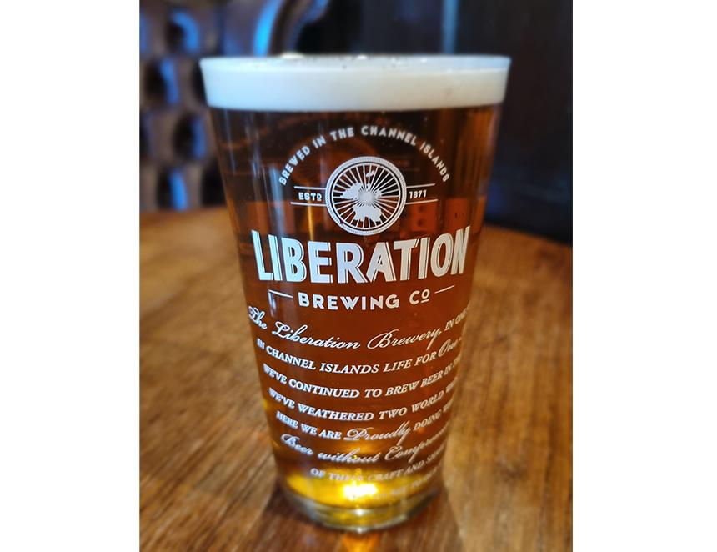

One of the most difficult concepts in winemaking is 'terroir,’ a combination of the type of soil, location and climate. These affect how and what grapes grow, long before the winemaker works their magic. For some wine drinkers, terroir takes on an almost spiritual level of connection. But does the same hold true for beer? Beer enthusiasts will straight away see the similarity in terroir to the importance of water chemistry in brewing and how many breweries operate with their own aquifers and boreholes. The mineral salts in the water can change the perception of bitterness and even the mouthfeel of the finished product. However, is there the same visceral connection between brewing and its location? How important to you is where your beer is brewed? I ask because the Butcombe Group has announced it is to close its Channel Islands brewery this month. The brewery in various guises has operated for more than 150 years in Jersey. A pedigree that not even the German occupation interrupted. Brewing started in 1871 when JS Palmer set out brewing “prime ales and porters of a superior quality”. But the name many people will associate with beer in Jersey, Ann Street brewery, wasn’t incorporated until 1905. Near the end of the century the company merged with another Jersey institution, the Tipsy Toad brewery, founded by Steve Skinner and it then moved from the Anne Street premises to its present location on the edge of St Helier. Renamed Liberation brewery it went on to produce a number of award-winning ales including Liberation Ale, Liberation IPA and Herm Gold. More recently the company went on another UK expansion and recently changed its name to Butcombe Group reflecting the huge success it has had in growing in Southern England. In its release Butcombe Group cited the increased costs of doing business as the key factor in its decision. JD Wetherspoon boss Tim Martin used his company’s recent results to highlight the upcoming increases in National Insurance contributions and National Minimum Wage as further pressures on pub companies. In Jersey, just like the UK, there have been increases in labour costs, raw materials, and persistent inflation as well as the additional freight charges, with just about everything having to be bought in by ship. A recent positive move by the island’s government to reduce the duty on the price of a pint by introducing a 5.4p tap relief is not going to be able stop the decline in beer sales and many of the island’s pubs now rely on food for the majority of their income. Butcombe said it remained committed to its involvement in the Channel Islands with its pub and wholesaling operations. Liberation brewery’s head brewer Pat Dean is to move along with some of the company’s small batch brewing equipment to Butcombe’s Wrington brewery to oversee the continued production of the former’s beers and help develop the company’s range of seasonal and specialist brews. I know Pat, and his passion and knowledge are a real asset to the company and Butcombe has invested heavily in its UK production facilities and brews many of its key product lines in house which is a big positive. If the brewery in Jersey was an attractive Victorian building with tours or a modern facility with a taproom, I have no doubt that it would be staying open. Unfortunately, the old town brewery was sold for redevelopment by a previous owner. Predictably the closure has generated a huge amount of coverage and comment on the island, but it meant little to the punters queuing up for a pint when I popped into a town-centre pub. The brewery was not a major attraction like the island’s war tunnels, coastal walks and stunning beaches but the closure is a blow to keeping things local and reducing food and drink miles. Will some retailers stop selling the companies beers as it is no longer a local product? Maybe. Will visitors sitting in the pubs and bars still drink Liberation Ale? I’m pretty sure they will, and I don’t think they will notice the change. Personally, I’m sad that such an important piece of island heritage is ending but if it means the company is continuing to brew cask beer and investing in the future then not all is lost.