Research says ‘craft’ devalued

12/10/2025 by Dave Pickersgill

Industry

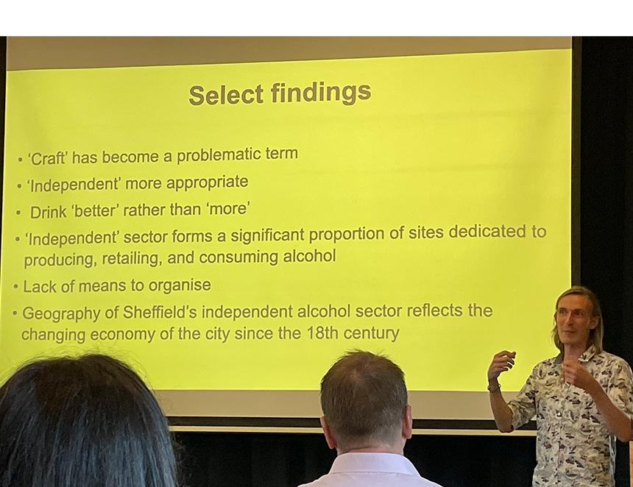

University of Sheffield research has found the term craft has been devalued as it has been taken up by multinationals. The research by Prof Phil Withington and Dr Nicholas Groat explored the place of 'craft' alcohol in the city looking at the past, present and future. Sheffield was chosen as it is known as the 'UK capital of beer' with a high density of small breweries mirrored by a large proportion of independent pubs, bars, and specialist off-licences. After revealing 'craft' has been devalued, the report suggests 'independent' is more appropriate as it captures a commitment to small-scale, autonomous artisanship, passion, skill and community. The study also shows how the independent sector’s geography reflects Sheffield’s long history as a city of neighbourhoods and how the values and working practices of the sector can contribute to a sustainable and vibrant future. The independent sector forms a significant proportion of sites dedicated to producing, retailing and consuming alcohol. The survey found 42 per cent of its sample (464) were independent.  Other findings include an emphasis on drink better not more. In addition, the quality of ingredients, culture of drinking environments and responsible and considerate habits are also important. The lack of a way for the sector to organise was also noted. Recommendations include: – use ‘independence’ not ‘craft’ – form a Sheffield indy drinks hub as the collective voice of the sector – explore how other places with concentrations of independent producers organise and market themselves – promote Sheffield’s unique heritage – strengthen partnerships with local authorities. The full report and a summary is available at: sites.google.com/sheffield.ac.uk/place-craft-and-alcohol Pictured: Dr Groat at the report launch (Dave Pickersgill)