CAMRA Pub Heritage Group update – October

11/10/2025 by Tom Chapman

Campaign

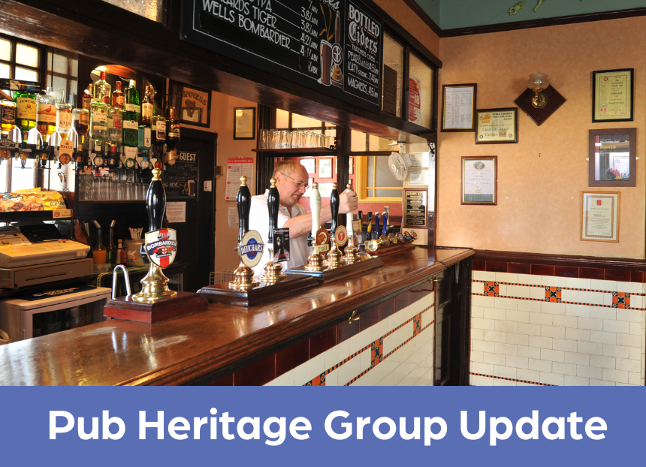

CAMRA’s Pub Heritage Group shares news and updates about pubs with historically significant interiors across the UK. For further news see the Pub Heritage Group webpage here. Three Star Heritage Pubs  Golden Ball, York, North Yorkshire Victorian, street-corner local, the Golden Ball (above), has been run by the Golden Ball Cooperative, a Community Benefit Society (CBS), since 2012, and has become very popular with its community. The freehold has been put up for sale without warning by owner Stonegate and is being marketed by Savills for £575,000. The CBS has recently agreed a lease that runs until 2043. This would continue with any new owner of the freehold, so there appears little danger of the pub shutting as a result of the sale. The CBS has also registered the pub as an Asset of Community Value (ACV), which means that it cannot be sold to another party before the society is given the opportunity to make a bid, plus it would be given six months to raise the money for the purchase. This is a golden opportunity for the CBS to secure the freehold and it is seeking clarification on the situation from York City Council and Stonegate.

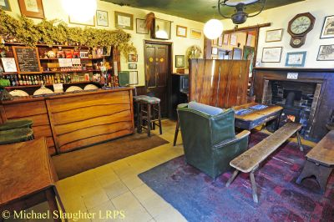

Queen’s Head, Newton, Cambridgeshire (above) A “new” room, which was historically part of the pub, has been brought back into use. Accessible via a doorway in the Saloon Bar, the new room will increase the pub’s capacity. Part of the rear garden has been opened for public use also. The pub, which dates back to 1729, has been owned and run by the Short family since 1962. The Queen’s Head is one of the Famous Five pubs which has featured in every edition of the Good Beer Guide since its inception in 1972. To celebrate its 50th year in the guide, the BBC published an article in 2022 here.

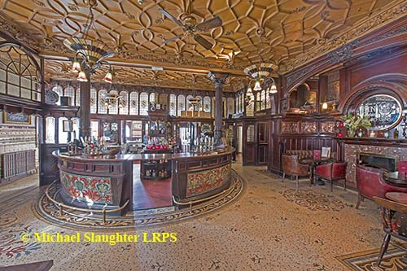

Philharmonic Dining Rooms, Liverpool, Merseyside (above) The magnificent Philharmonic has reopened following a £500,000 refurbishment by owner Nicholson’s. Originally completed in 1900 and designed by Walter Thomas, the Grade I-listed pub is recognised as the most spectacular in England. Due to the pub’s listed status, the refurbishment was restricted to restoration of the stained-glass windows and the magnificent art nouveau gates, as well as new carpets and furniture. The Grade I-listing resulted from a joint project in 2019 by CAMRA and Historic England to improve the listing descriptions of National Inventory pubs. Read more in the Liverpool Echo here.

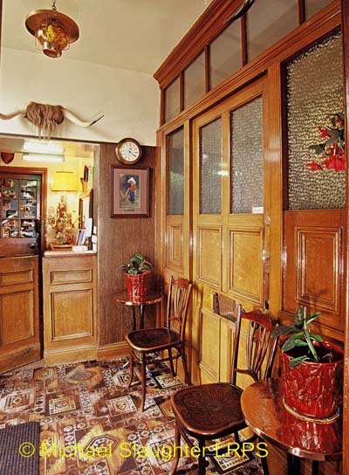

Star Inn, Netherton, Northumberland (above) The Pub Heritage Group reported in the August Bulletin that the group’s listing application for the Star had been successful and that this rare survival now had the extra recognition and protection it deserves. However, the listing does nothing to require an owner to keep a precious historic pub open or develop its undoubted potential. The Pub Heritage Group has written to the chairman of the parish council, urging that the pub is recognised as an ACV. This will be considered by the parish council at its next scheduled meeting in early November. Two Star Heritage Pubs

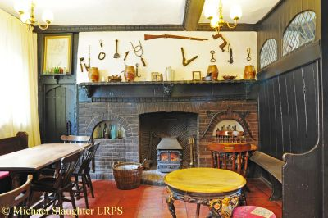

Green Dragon, Wymondham, Norfolk (above) The pub reopened on 19 September with new tenants following a succession of licensees in the last few years as covered in the April bulletin. The building dates to 1378 and it has functioned as an inn since the 16th century. One Star Heritage Pubs London Inn, Padstow, Cornwall A recent refurbishment to this pub has resulted in all the old fittings being stripped out. Consequently, it has been removed from the Inventory.  Other news Heritage Award Nominations are open for CAMRA’s Heritage Award. This celebrates the successful revitalisation of a heritage pub that is included on the National Inventory of Historic Pub Interiors with Three, Two or One Star status and is run in tandem with CAMRA’s Pub Saving Awards. The award will be given to a pub or operator that has carried out activity leading to the reinvigoration of the site for the benefit of the business or community. Success criteria are not limited to conservation of the pub interior. Pubs can also win the award through the efforts of its management to run the pub enthusiastically, care for its heritage and making a positive contribution to the community. Pubs are eligible for the award if this is done before 1 November 2025. The closing date for nominations is 12 November 2025. Find more information, eligibility criteria and the nomination form here. Last year’s inaugural award was won by the Drewe Arms, Drewsteignton with the Kings Head, Bristol claiming the runner-up spot. Pub Design Awards The annual CAMRA Pub Design Awards are now also open for nominations. Categories include: New Build, Community Local, Historic England Conservation, Conversion to Pub Use and Refurbishment. Many inventory pubs have received Pub Design Awards over the years, particularly in the conservation category. Last year the Forester, Ealing won the Community Local Award and in 2024 the Conservation Award was won by the Vines, Liverpool.  The deadline for applications is 17 November 2025. Any nominated project must have been completed between 1 July 2024 and the 30 June 2025. Find out more here.  Neepsend booklet   The third booklet in the Sheffield pub heritage walk series is now available. Sponsored by Alder Bar and the Gardeners Rest, it concentrates on the Sheffield area of Neepsend, the “new Kelham Island”. The booklet costs £2.99 and is available from Abbeydale brewery, Beer Central, Biblioteka, Crow, Draughtsman (Doncaster Railway Station), Famous Sheffield Shop, Forest, Gardeners Rest, Hop Hideout, Kelham Island Books and Records, Millennium Galleries, Rhyme and Reason and St Mars of the Desert.  For copies by post and retail enquiries, contact: pubheritage@sheffield.camra.org.uk  The official launch will be at the Sheffield Steel City Beer Festival (15-18 October). The series will continue with Kelham Island in 2026 and Riverside in 2027.  Dave Pickersgill has also shared a short audio piece where he talks about the history of Fagan’s, the One Star status pub in Sheffield. Listen on BBC Sounds here.   If you have any news on heritage pubs, send to: info@pubheritage.camra.org.uk   Feel free to forward this bulletin to your friends who are also interested in visiting pubs like these. If you wish to receive the bulletins directly, sign up by sending an email to bulletin@pubheritage.camra.org.uk with the word “subscribe” as the subject or “unsubscribe” if you wish to stop receiving bulletins.   Photos by Micheal Slaughter