Government fast track longer pub hours

10/10/2025 by Timothy Hampson

Industry

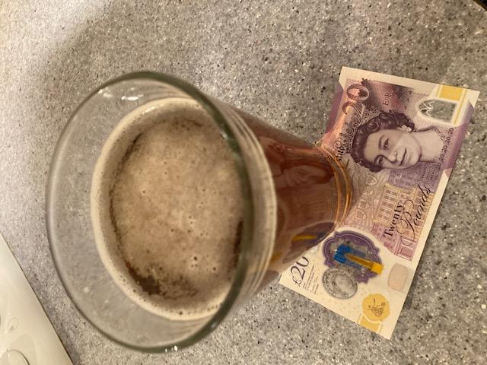

The government is leading a fast-track bid to cut “red tape” thought to be making it hard for pubs to host live music and food pop-ups. And pubs, clubs and restaurants will be able to open into the early hours as part of Labour’s drive for economic growth, a move which critics say will lead to more drunken disorder. Ministers are pushing ahead with plans to allow premises that sell alcohol to extend their opening hours in order to boost “the British night out” and help the hospitality sector. The prime minister said pubs are “the beating heart” of communities in the UK, after the government launched a four-week “blitz” survey of landlords, customers and neighbours. It is understood the exercise could lead to scrapping old licensing rules, amid fears some historic venues have shut over noise complaints or advertising concerns. “Pubs and bars are the beating heart of our communities,” Sir Keir said, and added the government was “backing them to thrive”. “This review is about cutting red tape, boosting footfall, and making it easier for venues to put on the kind of events that bring people together. When our locals do well, our economy does too.” Hospitality businesses are urged to support the measures and respond to the call for evidence, which closes on 6 November, to ensure the measures move to implementation. UKHospitality chair Kate Nicholls said: “Moving to a new and improved licensing system that works for modern hospitality businesses is critical, and I’m pleased the government is acting swiftly on the recommendations of the Licensing Taskforce. “The taskforce, steered by UKHospitality and other industry leaders, resolved to recapture the original intent of the Licensing Act to encourage growth and meet consumer needs. “The measures we’ve put forward and now taken on by the government, including the National Licensing Policy Framework and licensing condition amnesty, help to achieve that goal. “During this call for evidence, I urge all hospitality businesses to support these measures, to ensure that they are delivered in full. “However, I am clear these changes are absolutely not a silver bullet to solve the existential cost challenges hospitality businesses are facing. “While we have grasped this once-in-a-generation opportunity to modernise the licensing system, we continue to campaign vociferously for material change to reduce the sector’s cost burden at the Budget. “Hospitality is being taxed out, and we need the government to lower business rates, fix NICs and cut VAT to reverse the damage done by last year’s Budget, which has so far seen 84,000 hospitality jobs lost.”