Reverend to open beer festival

09/10/2025 by Dave Pickersgill

Campaign

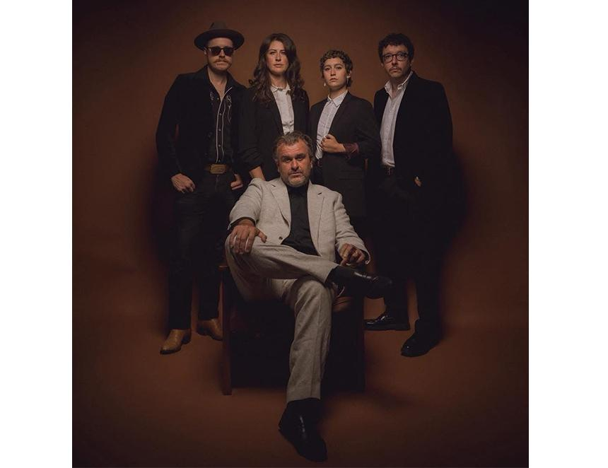

The 49th Sheffield Steel City Beer and Cider Festival (SCBF49) will be opened by local musician Jon McClure, lead singer of the city-based band Reverend and The Makers.  The band is celebrating its 20th year with a new line-up and a series of festival gigs. The latest single, Haircut, features vocals from actor Vicky McClure (Line of Duty, This Is England, Broadchurch). After an appearance on BBC’s The One Show it went to number one on the iTunes download chart. The track is taken from the band’s eighth album, Is This How Happiness Feels? The festival will take place at Kelham Island Industrial Museum from 15-18 October.