No half measures at festival

08/10/2025 by Timothy Hampson

Campaign

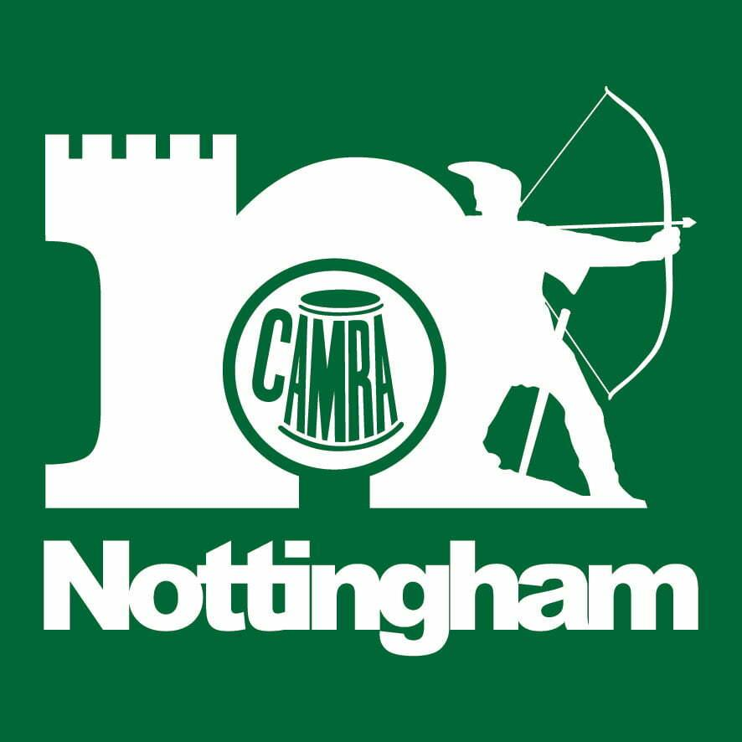

The Nottingham Robin Hood Beer & Cider Festival opens to the public tomorrow and sees a return of the No Half Measures (NHM) bar. The concept behind it is to emphasise that women can and do have a place in the beer industry. All the beers on the bar are from women-led breweries; either run by them or with a female brewer. It was launched last year and it is back with even more women-led beers with over 50 on the NHM bar alone. NHM is a collective of women in Nottingham who either work in the brewery or hospitality trade, or who just like drinking good beer. Primarily a social group, NHM also runs events and pushes for inclusivity. Four of the beers on the bar are collabs between the group and breweries, including Lovelaced, a hoppy EPA brewed with Nottingham Brewery and Summit She Brewed, a 4.5 per cent golden ale designed with Linzi, head brewer at Full Mash in Stapleford Organiser Wendy Westby said: “We’re looking forward to running the bar again this year. “There are some amazing beers made by women, and some amazing women who appreciate good beer. We’re trying to move away from the typical view of a CAMRA beer festival being a very male space and to show that it’s normal for women to know about and enjoy beer. “All the knowledgeable and enthusiastic staff on the NHM bar are women and we will be a welcoming space for women… and men, we aren’t discriminatory!” The 2025 festival, after suggestions from the public, has found a way of keeping visitors updated on the availability of beers and ciders. A CAMRA app has been created which can be downloaded at the event and is also available on its website. As new beers and ciders are put on, the app will be updated so visitors will not only know what is available, in real time, they will also know where they are on the site. After a gap of some years the East Midlands SIBA (Society of Independent Brewers and Associates) beer judging takes place today, so visitors will be able to sample the winning entries. The festival’s public sessions open tomorrow and will again be held at the Trent Bridge Cricket Ground. Today’s sessions are reserved for the trade and CAMRA members. The event runs until Saturday 11 October (12.00 noon to 10.30pm). Tickets are available in advance at trentbridge.co.uk/robin-hood-beer-and-cider-festival.html and can also be bought on the door.