Thimble has drinkers award sewn up

06/10/2025 by Timothy Hampson

Campaign

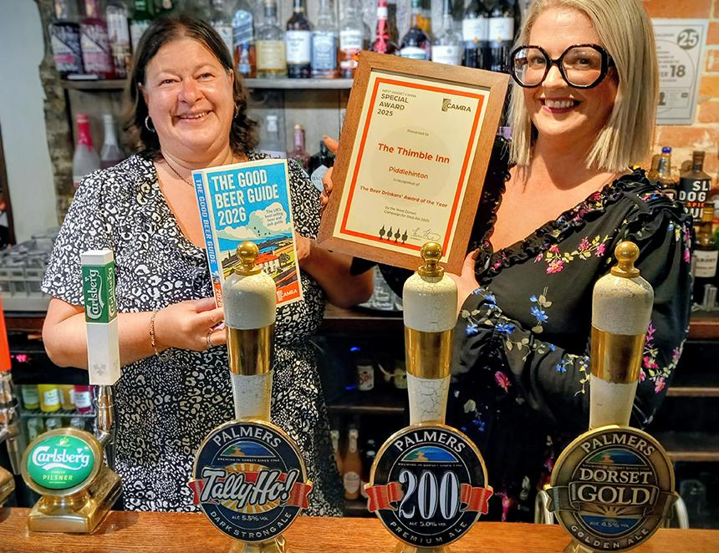

West Dorset CAMRA has announced the Thimble Inn, Piddlehinton is the winner of its 2025 Beer Drinkers Pub Of The Year award. The unique award is given to the pub that consistently serves the best cask beer assessed by CAMRA members, judged throughout the year using the National Beer Scoring System via the Campaign’s website. Every month the scores are presented at CAMRA branch meetings and during the past year the Thimble Inn has led the way, standing out as consistently good. Thimble Inn licensee Emma-Jayne Trawicki said: “We are incredibly grateful to have been chosen as CAMRA’s Beer Drinkers Pub Of The Year. “Our team works tirelessly to make the Thimble a welcoming environment where everyone can come and enjoy a good pint. It is fantastic that we have been recognised by CAMRA for this.” West Dorset CAMRA spokesperson Rich Gabe said: “Overall beer quality in West Dorset is getting consistently better year by year and this award is a reflection of the good cellarmanship at the Thimble Inn. “This is only the second year we have presented this award and there was a lot of strong competition, well done to Emma-Jayne and her team.” Pictured, from left, West Dorset branch competition coordinator Kylie Stroud and Emma-Jayne Trawicki. (Picture: Rich Gabe)