Boost for pubs welcome but Budget support essential

03/10/2025 by Timothy Hampson

Campaign

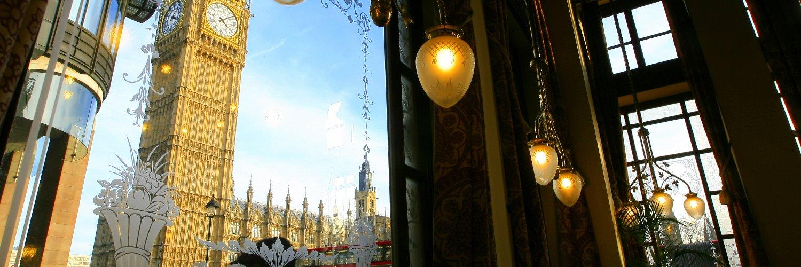

The government is to spend up to £5bn on boosting high streets, parks and public spaces in 339 “overlooked” communities across the UK. Under its Pride in Place programme, the government has also said it will give communities help to save pubs and libraries from closure and encourage local councils to block “fake“ barbers, as well as “unwanted“ betting and vape shops. CAMRA says the powers to save pubs are useless without a dedicated pub-saving fund and action in the Autumn Budget. CAMRA chairman Ash Corbett-Collins said: “Giving communities first refusal on buying their local to save it as a community-owned pub could be a game-changer but it is useless if those groups trying to save pubs can’t access funding to buy it before it is converted or demolished. “There are no guarantees that those areas getting new Pride in Place money will be able to spend it on saving and restoring pubs, and it appears there are no funds at all for communities outside of the areas selected today. "It’s great to see the prime minister talking about tackling pub closures, but today’s announcement is just the first step towards that. We need action on VAT, business rates and National Insurance contributions in the Budget, and the ongoing Access to Market Review for independent breweries needs to make fundamental changes to end the stranglehold that global brewers have on bars across the UK.”