MP opens new SIBA HQ

02/10/2025 by Timothy Hampson

Industry

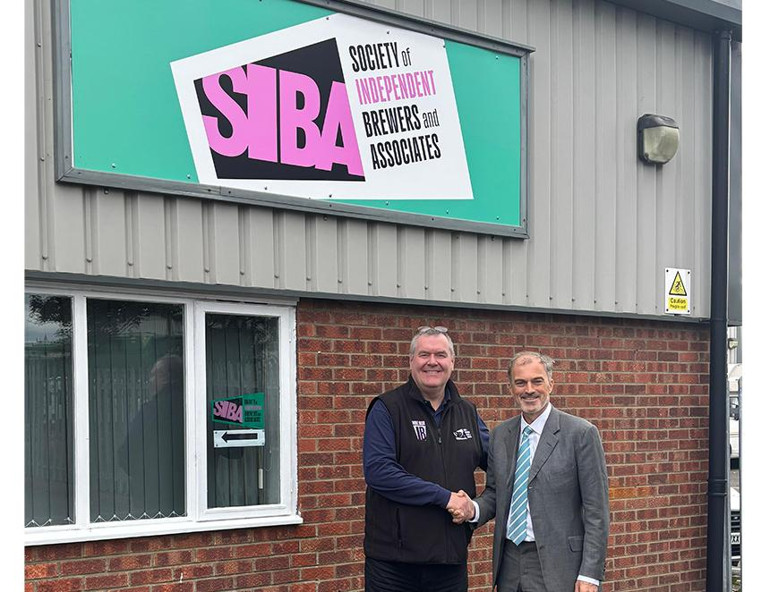

Sir Julian Smith, MP for Skipton and Ripon, officially opened the new headquarters of the Society of Independent Brewers and Associates (SIBA) in Ripon. Smith visited SIBA’s new premises on Dallamires Lane, where he was welcomed by chief executive Andy Slee and members of the SIBA team. Smith said: “I am grateful to open SIBA’s new office here in Ripon. Independent brewers are a cornerstone of our local and national economy, and I am proud that Ripon is now home to an organisation doing so much to support them. I look forward to seeing SIBA continue to thrive and champion the best of British beer.” The new office will serve as a hub for SIBA’s operations. Slee said: “Sir Julian has been a keen supporter of our sector for many years. It was great to welcome him to our new office in Ripon and share with him the opportunities and challenges facing Britain’s independent brewing sector. We know we have a friend in Westminster.” Pictured, from left, Andy Slee and Sir Julian Smith