Blackfriars’ joy at cider success

01/10/2025 by WB Reporter

Campaign

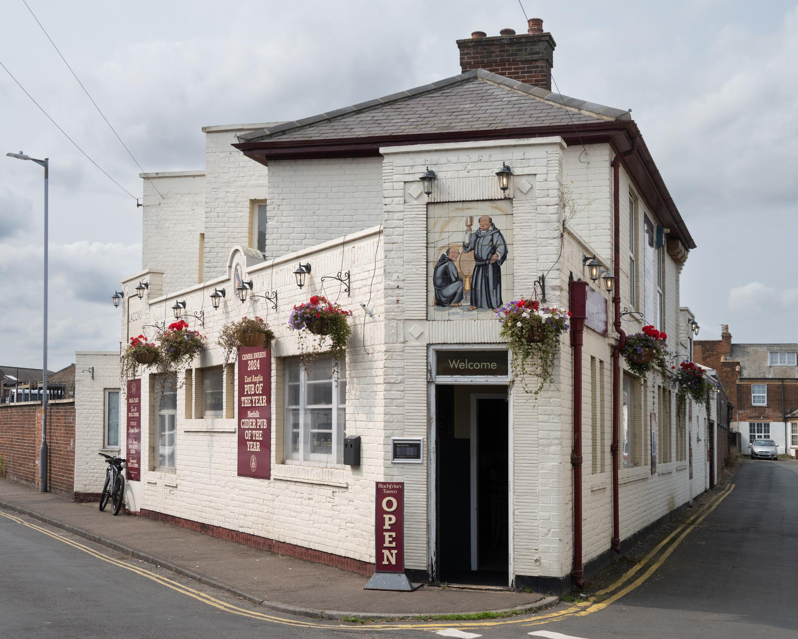

CAMRA’s Cider and Perry Pub of the Year 2025 crown has been won by the Blackfriars Tavern in Great Yarmouth.  The competition recognises the best pub or social club that champions real cider and perry across the UK. Judges are looking for great atmosphere, décor, welcome, service, inclusivity, overall impression and, most importantly, top quality cider and perry.  The Blackfriars Tavern is a Victorian corner pub, which has quickly become a must-visit destination for cider and perry lovers with more than 20 locally sourced real ciders available and some from further afield.  Not only has the pub, which is close to the 13th-centry town walls, won this top accolade, but it is also in the running to win CAMRA’s overall Pub of the Year title, as it is one of the UK’s top 16 pubs revealed in August.  Along with East Anglian ciders and perries, the pub stocks eight ever-changing cask beers with two permanently on the bar from the on-site Blackfriars Tavern brewery, plus a wide choice of bottled Belgian beers.  Blackfriars Tavern landlord and freeholder Pharez Smith said: “Oh my word, oh my word! We are overjoyed. This award is a tribute to our wonderful customers who create the welcoming atmosphere that makes our pub special. We also thank the incredible producers, whose skill and dedication fill our cellars with variety and quality.   “Five and a half years ago we began major renovations on this disused pub and what a journey it has been. We’ve loved connecting with our customers through a shared passion for real cider and perry. Finally, we are hugely grateful to CAMRA for their tireless work in championing these traditional drinks, and we are proud to be part of that story.”  Cider and Perry Pub of the Year coordinator Sarah Newson said: “Congratulations to the team at the Blackfriars Tavern – it is a real gem of a pub and well worth seeking out. With the pub winning CAMRA’s ultimate cider and perry accolade, and also in contention for winning overall Pub of the Year, this is an exciting time for pubgoers in Great Yarmouth and East Anglia.  “Along with the Blackfriars Tavern, our three finalists and all the regional and national winners in this competition show just how wonderfully varied the UK cider and perry scene is today. If your knowledge of cider or perry is limited to the large commercial brands sold cheaply in supermarkets, I urge you to seek out these pubs to see just how amazing and varied these traditional drinks really are.”  The other finalists were: Carpenters Arms in Westrip, Gloucestershire; last year’s winner That Beer Place in Chester, Cheshire; Bull and Dragon in Meeth, Devon.  Who won what East Anglia - Blackfriars Tavern, Great Yarmouth  East Central - Little R'Ale House, Wellingborough  East Midlands - Red Lion, Kniveton  Greater London - Owl and the Pussycat, Northfields  Merseyside and Cheshire - That Beer Place, Chester  North East - Blue's Micropub, Whitburn  North West - Petersgate Tap, Stockport  Scotland - Jolly Judge, Edinburgh  South Central - Woodman, Bridport  South East - Green Man, Worthing  South West - Bull and Dragon, Meeth  Wales - Myrddins Tap, Barmouth  West Central - Carpenters Arms, Westrip  West Midlands - Roberto's Bar, Halesowen  Yorkshire - Doncaster Brewery Tap, Doncaster  Photo: Helge Nareid