Find your next CAMRA festival

30/09/2025 by George Robbins

Campaign

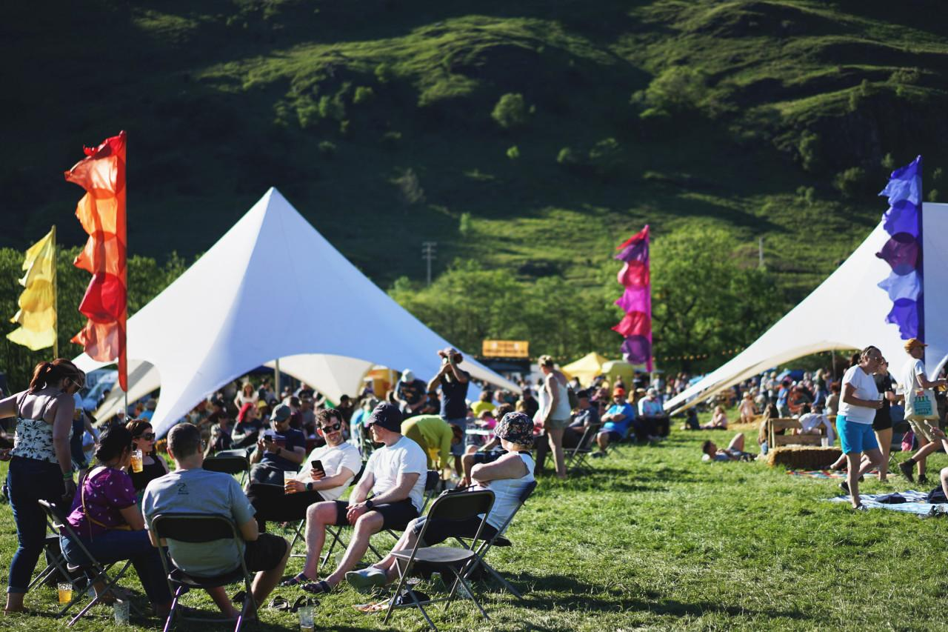

As summer comes to a close, beat those autumn blues by visiting one or more of the many festivals taking place over the next few months. Just pick from the list below. To see all upcoming CAMRA events, visit the events webpage.      Bedford Beer Festival, 1-4 October  Bedford Corn Exchange, 13 St Paul's Square, Bedford, MK40 1SL  northbeds.camra.org.uk/viewnode.php?id=243327     Ayrshire Real Ale Festival, 2-4 October  Municipal Buildings, South Beach, Troon, KA10 6EF  ayrshirebeerfestival.co.uk     13th South Woodham Ferrers Beer and Cider Festival, 2-4 October  South Woodham Ferrers Village Hall Social Club, 25 Hullbridge Road, CM3 5PL  maldonanddengiecamra.org.uk/swfbeerfestival     Carmarthenshire Real Ale and Cider Festival, 2-4 October  St Peter’s Civic Hall, 1 Nott Square, Carmarthen, SA31 1PG  carmarthenshire.camra.org.uk/index.php/carmarthenshire-beer-festival     18th Ascot Beer Festival, 3-4 October  Ascot Racecourse, Ascot, SL5 7JX  ascotbeerfest.org.uk     Weymouth Octoberfest Real Ale and Cider Festival, 3-4 October  Weymouth Pavilion, Weymouth, DT4 8ED  camrawdorset.org.uk/     Nottingham Robin Hood Beer and Cider Festival, 8-11 October  Trent Bridge Cricket Ground, Radcliffe Road, West Bridgford, NG2 6AG  nottinghambf.camra.org.uk/     Steel City Beer and Cider Festival, 15-18 October  Kelham Island Museum, Alma Street, Sheffield, S3 8RY  sheffield.camra.org.uk/festival     Carlisle Beer and Cider Festival, 23-25 October  Station Hotel, Court Square, Carlisle, CA1 1QY  solway.camra.org.uk/     Swindon Beer Festival, 23-25 October  Steam Museum, Firefly Avenue, Swindon, SN2 2EY  swindon.camra.org.uk/viewnode.php?id=23556     15th Gainsborough Beer Festival, 23-25 October  Blues Club, Northolme, North Street, Gainsborough, DN21 2HU  fenland.camra.org.uk/viewnode.php?id=5964     27th Worthing Beer and Cider Festival, 24-25 October  Rooms, 44 Guildborne Centre, Worthing, BN1 1LZ  aaa.camra.org.uk/wbf     Redhill Beer Festival, 30 October-1 November  Merstham Village Hall, Station Road North, Merstham, RH1 3ED  ems.camra.org.uk/festival    Hull and EY CAMRA Real Ale and Cider Festival, 30 October-1 November  Minerva Masonic Hall, Prince Street/Dagger Lane, Hull, HU1 2LJ  hull.camra.org.uk/    Poole Beer Festival, 31 October-1 November  St Aldhelms Center, Poole, BH12 1AD  eastdorset.camra.org.uk/index.php/festivals/poole-beer-festival/    15th Woolston Beer Festival, 31 October-1 November  Pear Tree Church Hall, 80 Peartree Road, Woolston, Southampton, SO19 7RT  woolstonbeerfestival.camra.org.uk/    Belfast Beer and Cider Festival 2025, 6-8 November  Banana Block, Portview Centre, Belfast, BT4 1HE  belfastbeerfestival.co.uk/    Alloa Real Ale and Cider Festival, 7-8 November  Alloa Town Hall, Marshill, FK10 1AB  facebook.com/events/1412826513278691    Southend Beer and Cider Festival, 20-22 November  Naval and Military Club, 20 Royal Terrace, Southend, SS1 1DU  see.camra.org.uk/viewnode.php?id=14968    Newark Beer and Cider Festival, 21-22 November  Newark Town Hall, Market Place, Newark-on-Trent, NG24 1DU  newark.camra.org.uk/beer-festival/    Dudley Winter Ales Fayre, 27-29 November  Dudley Town Hall, St James’s Road, Dudley, DY1 1HP  dudley.camra.org.uk/viewnode.php?id=261624   Pig’s Ear East London Beer and Cider Festival, 2-6 December  The Round Chapel, 1D Glenarm Road, Hackney, E50LY  facebook.com/pigsearcamra    Cambridge Winter Beer Festival 2025, 10-13 December  Cambridge Corn Exchange, 2 Wheeler Street, Cambridge, CB2 3QB  cambridgebeerfestival.com/event/cambridge-winter-beer-festival-2025/    Photo by Matthew Curtis