Pubs’ social value revealed

29/09/2025 by Timothy Hampson

Industry

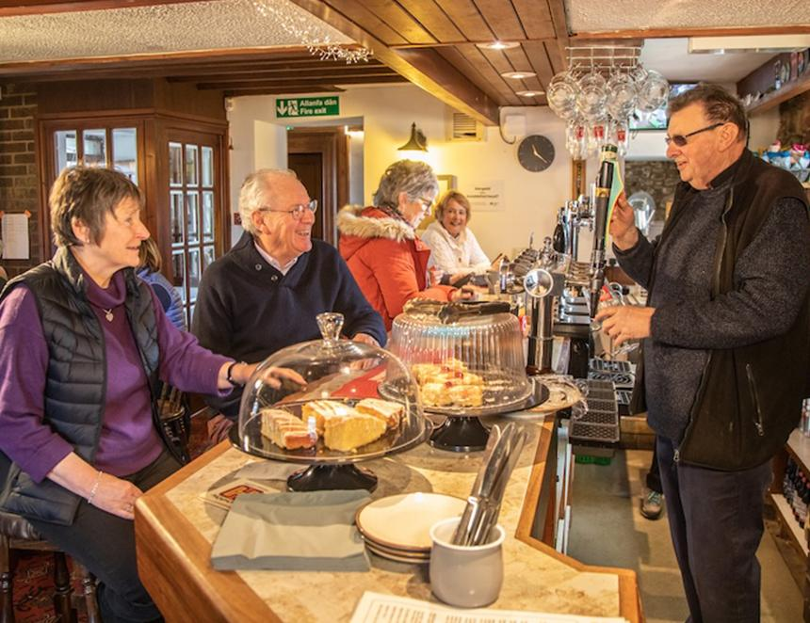

British pubs and publicans have been at the heart of their areas for centuries meeting social needs and connecting communities, but new research has put a figure on just how much social value they bring. The groundbreaking research comes from Pub is The Hub, the not-for-profit organisation that helps locals to diversify and provide essential services and activities. Called Pub is The Hub: Social Value, it has established that for every £1 invested in services and activities in the local, an average social value worth £8.28 is created.  It confirms pubs offer social value that supports community cohesion, job security, well-being, increased social interaction and resilient communities. The report also reveals pubs help people to overcome social isolation and replace the loss of services in rural and deprived areas. Backed by the National Lottery Community Fund, the report measures the social value delivered by publicans and their pubs, through Pub is The Hub support, to help provide a range of vital services and activities in their areas.  Calculating social value is an academic process that measures the added value an initiative brings to society and refers to the wider positive impact an activity, project or organisation has beyond just financial or economic returns. The evaluation, which focuses on Pub is The Hub projects implemented between 2022 and 2024, analysed the impact of adding new services and activities. It examined how the introduction of amenities such as stores, cafes and allotments, as well as events such as theatre and arts performances, help to reduce social isolation and address community needs. The evaluation also highlighted the crucial role of the publican in these efforts. It concluded diversified pub-based initiatives will have lasting effects on the overall improved local well-being for individuals and their families as well as in reducing loneliness, improving mental health and giving people greater independence. The evaluation also found the social value created by pubs meets several of the UN’s Sustainable Development Goals. It aligned the Pub is The Hub projects with a broader impact including tackling issues such as poverty, inequality, good health and local wellbeing. Pub is The Hub chief executive John Longden said: “Publicans and their pubs have a vital social role in supporting local communities and helping people to overcome social isolation and alleviate feelings of loneliness. They have a significant social value that is beyond economic impact. They are crucial in helping to bring people together and helping with the provision of lost services and amenities. “There needs to be wider recognition of the important role that individual publicans and the vital role their pubs have in rural communities and deprived areas as social hubs. Pubs contribute to the general wellbeing of locals and help drive social cohesion and community resilience in local areas.”