Keep Cask Alive!

28/09/2025 by WB Reporter

Campaign

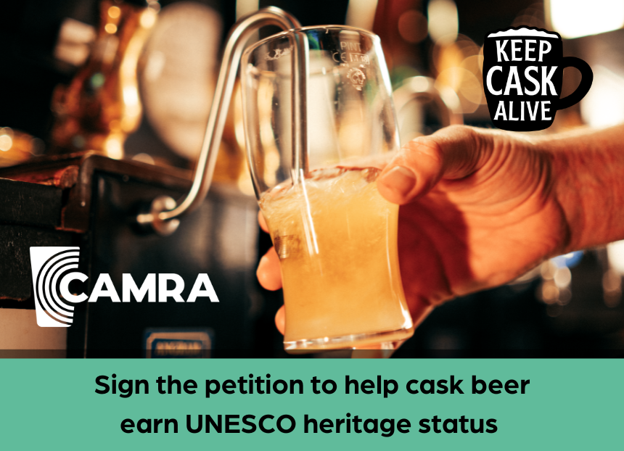

Time is running out to be part of the Keep Cask Alive campaign to get cask beer the protection it deserves from the UK government and UNESCO.  CAMRA has been backing the Craft Beer Channel’s petition to see the production and serving of cask recognised as Intangible Cultural Heritage.  More than 40,000 signatures have been recorded to date, but 100,000 are needed to secure a debate in parliament. The petition ends on 1 October and you can sign here.  The UK government has already noted the petition and said it would welcome an application to list cask beer as part of its inventory to recognise intangible cultural heritage in the UK.  The UNSECO petition was revealed in the concluding episode of the Craft Beer Channel’s Keep Cask Alive video series, which saw CAMRA chairman Ash Corbett-Collins talk about the importance of campaigning for cask and the hard work CAMRA volunteers do to protect this traditional drink.  The series follows Jonny Garrett and Brad Evans as they travelled across the UK, visiting breweries, pubs, festivals and farms to highlight the challenges and opportunities facing cask.  You can view the episode here.