Bumper harvest triggers expansion

26/09/2025 by Timothy Hampson

Industry

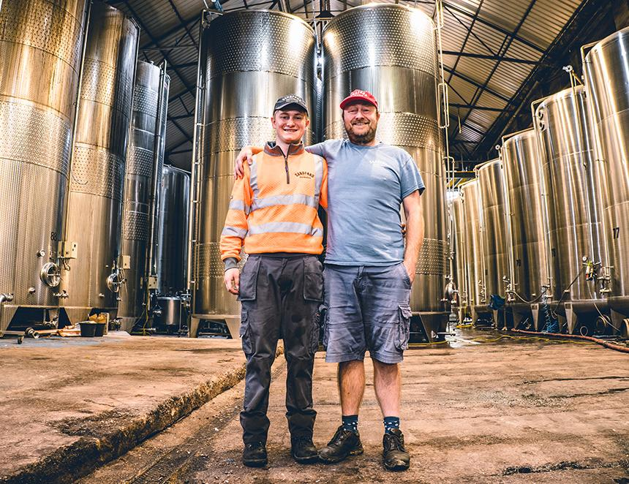

Devon-based Sandford Orchards has just installed eight 50,000-litre tanks ahead of a bumper harvest expected to be up to a third larger than normal. The company plans to increase production of its core ciders and create new varieties from this year’s exceptional apple haul. Owner Barny Butterfield said: “Anyone with fruit trees in their garden is likely to be experiencing a record crop this year and we are no different. “A mild spring and the sunniest summer for some time has left our trees groaning under the weight of fruit, and we’re looking forward to a harvest around a third bigger than last year. “That’s around 4,000 tonnes of apples! In fact, it looks set to be the biggest harvest I have experienced in my lifetime as a cider maker. “The very un-British weather has also meant that the apples are ripening ahead of schedule and were already beginning to drop in late August, so it’s all happening a lot earlier than normal. “We don’t usually start harvesting our apples until early October but this year looks set to be different. All our fruit comes from local orchards so we are able to make regular checks on them to identify the optimum moment to harvest. “Our inspections throughout the summer have already indicated that this year is set to be an epic harvest and in anticipation of that we have invested in eight new tanks which will increase our capacity by 400,000 litres. “The extra hours of sunshine that the apples have enjoyed this year should also have boosted sugar levels, which means this could be the sweetest and largest harvest on record for us. “With our newly increased capacity and these fantastic raw ingredients, we will be pressing six days a week from 5am until 9pm to produce more bottles of our much-loved ciders for next summer’s cider drinking. “We will be pressing at least 70 varieties and, among them, there are going to be a lot more of the rare apples that we have been identifying in our DNA mapping project. So we'll be able to do some really interesting small-batch blends with them too.” Pictured: Barny (right) and Eliott Butterfield with the new tanks