Latest Good Beer Guide is ‘testament to resilience of publicans’

25/09/2025 by Timothy Hampson

Campaign

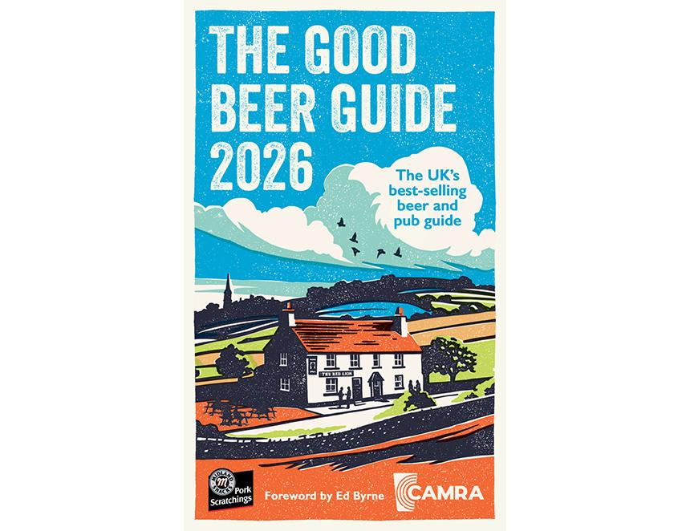

CAMRA has published the 2026 Good Beer Guide (GBG) along with a clear message to the chancellor that it is a make-or-break moment for the future of independent brewers and consumer choice. The GBG is the definitive guide to pubs that serve great cask beer across the UK​, and uses an independent, volunteer-led selection process that makes it the authoritative and trusted voice of cask beer drinkers. However, CAMRA warned the latest figures show another drop in brewery numbers across the UK, almost all of them smaller and independent operators, which the Campaign said are vital to consumer choice.  No less than 149 breweries have closed and only 71 have opened. CAMRA has also revealed 35 pubs that featured in the 2025 guide have closed. One has been converted and the rest are shut with an uncertain future. There are 900 new entries in the new guide, showing pubs are beating the odds to provide quality and choice despite tough economic conditions. In a year where parts of the UK’s brewing heritage, such as Banks’s in Wolverhampton, closed their gates for good, the guide remains the go-to source for finding choice and quality in pubs.  CAMRA chairman Ash Corbett-Collins said: “This really is a make-or-break Budget for the chancellor. It’s time for the government to decide if it is pro pubs and independent brewers, or if it is going to reign over the demise of the great British pub. Consumers want decisive action to get independent beers onto bars and allow pubs to thrive. “Each edition of the Good Beer Guide is a collectible snapshot of beer and pub culture that year. This year’s guide is a testament to the remarkable resilience of publicans, continuing to achieve excellence and choice for consumers despite a backdrop of sky-high tax bills and a lack of action from government. The chancellor needs to use the upcoming Budget to slash the tax burden on pubs, including VAT, duty and National Insurance contributions." The 2026 GBG is sponsored by Midland Snacks Traditional Pork Scratchings and endorsed by Cask Marque. Get your copy here: shop.camra.org.uk/product/good-beer-guide-2026/

