Record cider apple harvest forecast

24/09/2025 by Timothy Hampson

Industry

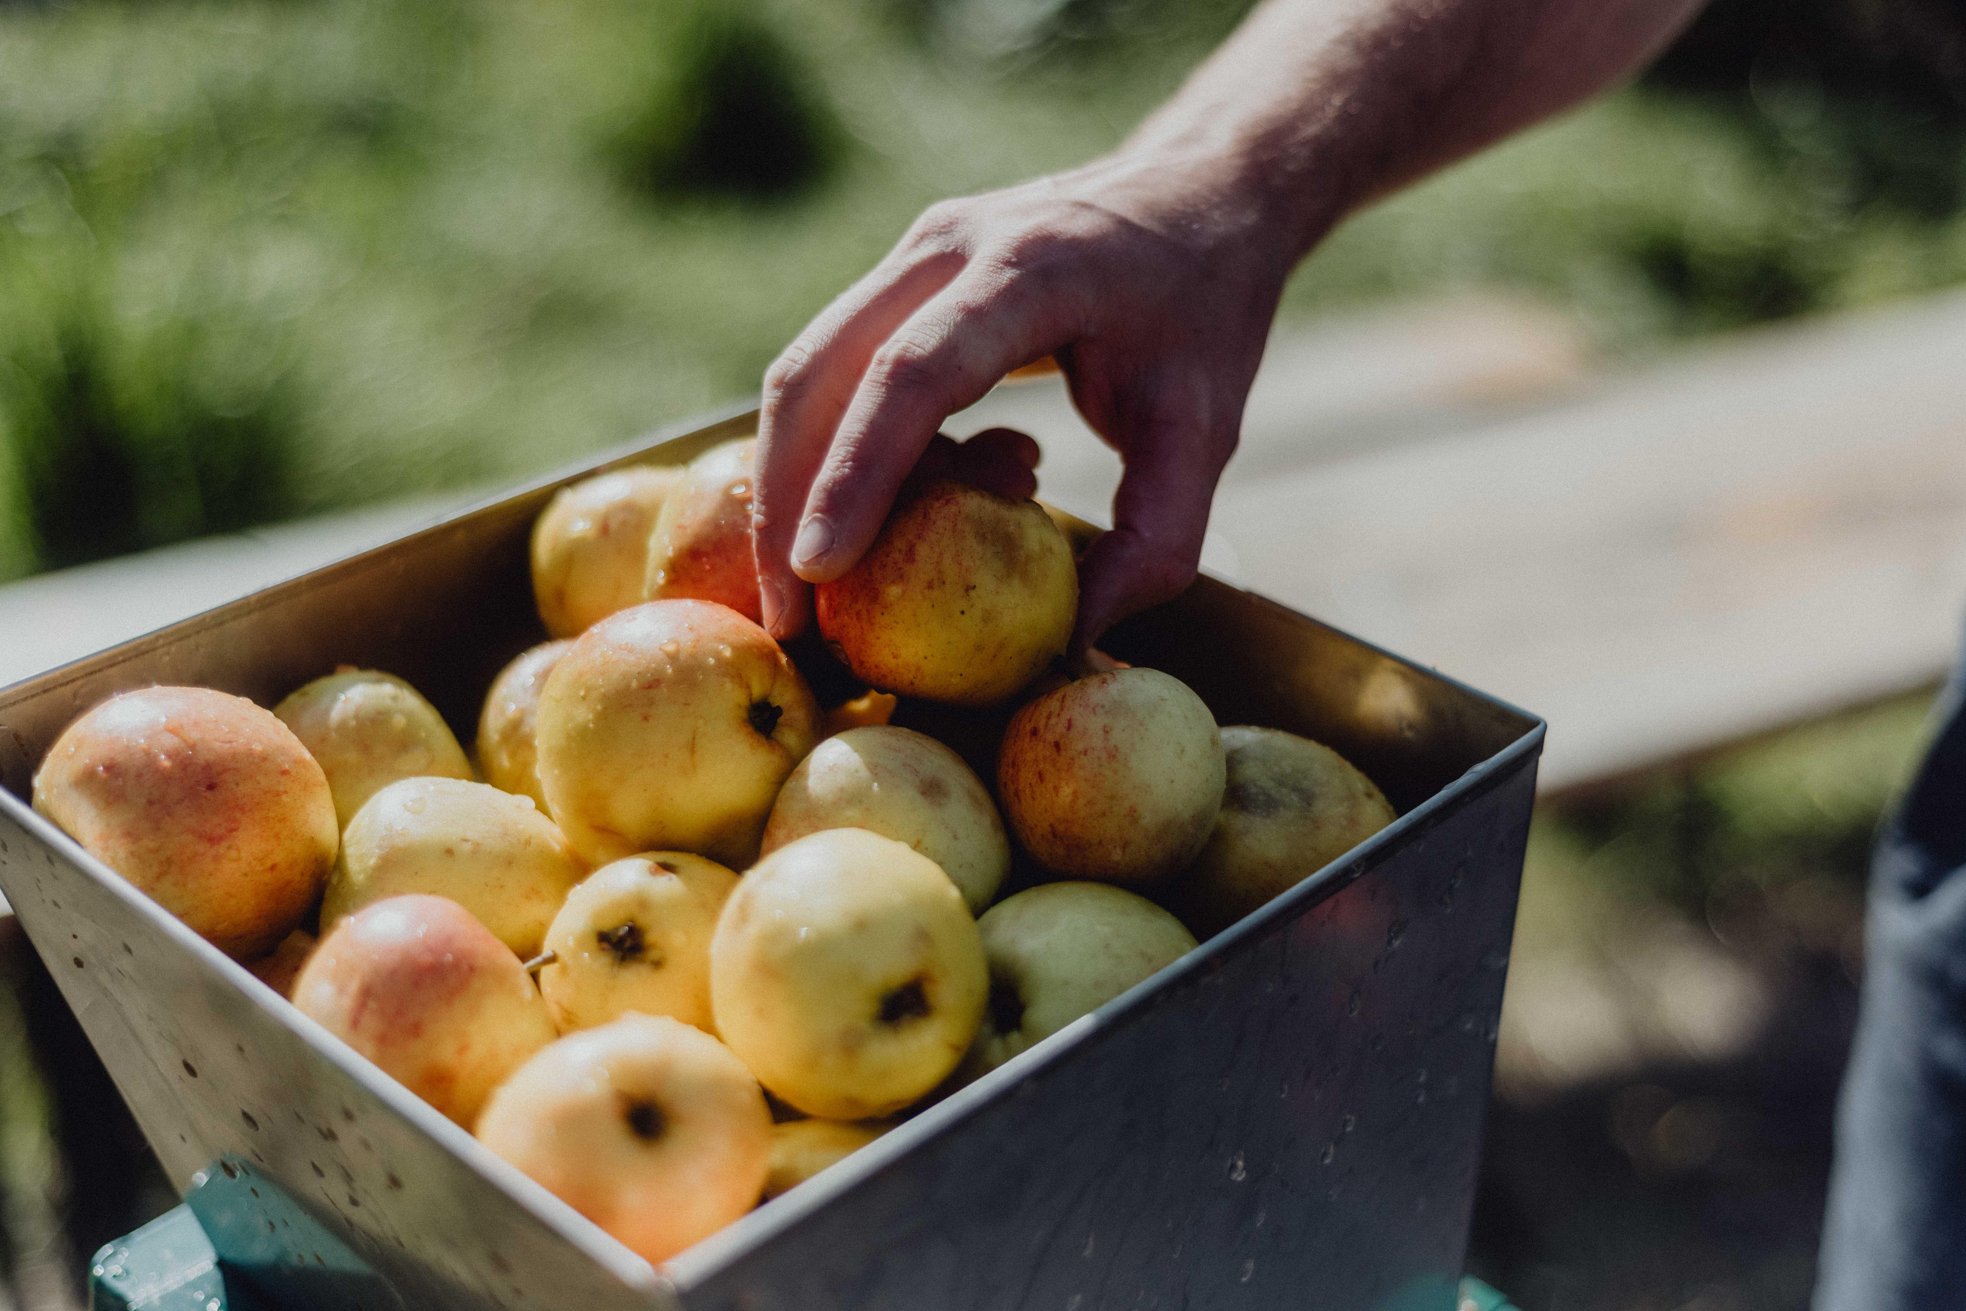

Britain is heading for a record-breaking apple crop with the long, hot summer producing super sweet fruit that promise an exceptional cider vintage. One of the country’s leading producers, Showerings, is expecting a “monster crop” of 2,500-3,000 tonnes of apples, compared to the 1,000 harvested last year. Orchard master Bob Wadley believes the heatwaves and sunshine boosted sugar content, while the recent rain allowed the apples to swell. England’s apples are mostly grown in Somerset, Herefordshire and Kent. Growers are having to contend with climate change, which is causing more volatile and unpredictable weather conditions. After two difficult years, growers agree that this year will see a dramatic recovery. Showerings director Nick Showering said: “A monster crop will be a gift after two challenging harvests, and the quality of the fruit so far is incredibly exciting”. British consumers are increasingly opting for premium and fine ciders, while cheaper traditional brands stagnate, according to the latest figures. The overall cider market in the UK is broadly flat, but emerging premium and fine categories are experiencing strong growth. Showerings is outperforming the sector, reporting a year-on-year increase in volume growth of 51 per cent.