Taste of Wivey in Westminster

23/09/2025 by Timothy Hampson

Industry

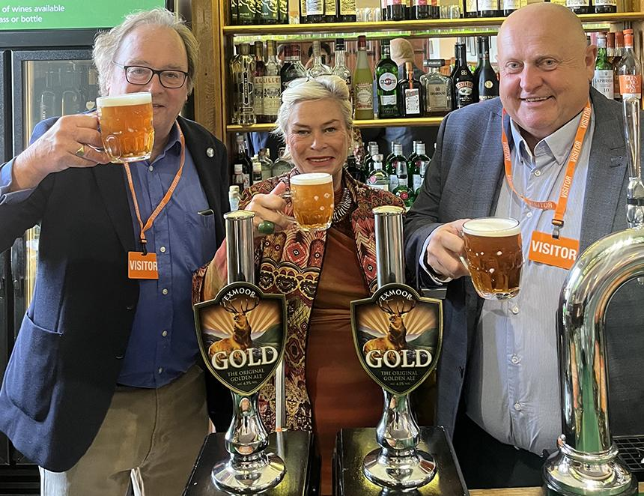

Exmoor brewery of Wiveliscombe, Somerset raised a glass of its popular Exmoor Gold at the seat of government after local MP Rachel Gilmour chose it as the guest beer in the Strangers’ Bar inside the House of Commons. Exmoor Gold, 4.5 per cent ABV, was the original “golden ale” in Britain, a style of beer now brewed by most breweries. Now coming up to its 40th anniversary, Exmoor Gold’s balanced, subtle, caramel maltiness with fresh citrus hop fruitiness, was enjoyed by the many MPs and other parliamentarians for whom the Strangers’ Bar is their local.  Tiverton and Minehead MP Rachel Gilmour said: “It has been an absolute pleasure to bring this wonderful beer to Westminster and introduce my colleagues in parliament to a taste of Wivey. “Wiveliscombe has a long and proud brewing tradition, to which Exmoor Gold firmly belongs. It is great to see the Exmoor brewery revived, which speaks to the passion for, and understanding of, the craft of brewing in Wivey.  “Not only has this saved jobs at Exmoor brewery, I am sure that it will prove a real asset to our constituency, with the potential for more roles to be created as the new brewery develops, supporting pubs that are at the heart of our local communities.” Exmoor chairman Jonathan Price said: “We were delighted that Exmoor Gold was selected for the Strangers’ Bar and grateful to Rachel Gilmour and the team at the bar for making it happen. We’re very proud of our beers and this was a great opportunity to spread the word about them beyond our usual area of trading.” “I’d love to think that a pint of Exmoor Gold may have inspired some of our politicians to dream up groundbreaking new policies in support of the beleaguered hospitality industry, but in any event, we are delighted that so many MPs enjoyed drinking it. “Thanks to the collaboration with Hogs Back brewery, which kickstarted Exmoor Drinks and helped us move into our new brewery, we’re able to remain independent and brew some of our iconic ales from our spiritual home in Somerset. We look forward to launching many new beers from our new brewhouse across the South West.” Pictured, from left, Jonathan Price, Rachel Gilmour and Exmoor head brewer Shaun Vockins.