Brewer’s shortlist hat-trick

22/09/2025 by Dave Pickersgill

Industry

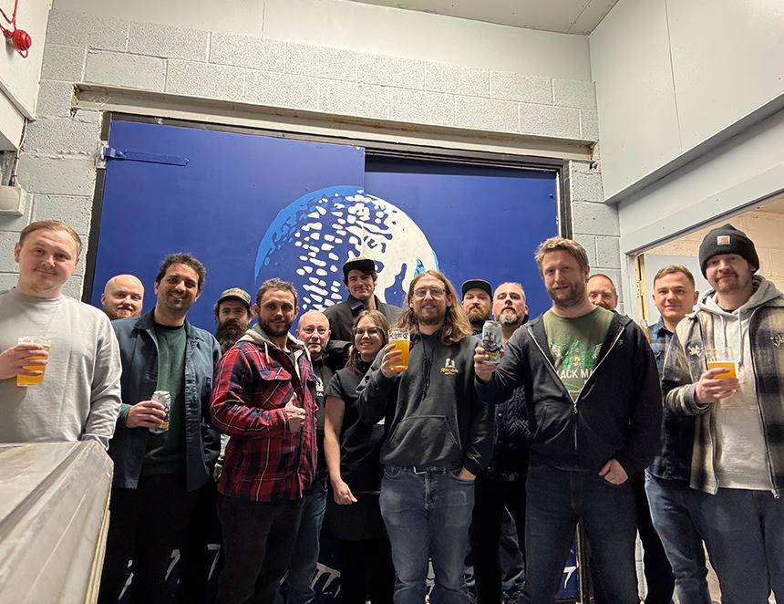

Sheffield’s longest-established brewery, Abbeydale is celebrating after winning a place on the shortlist for three national awards. It has scooped a top three spot in the Best Drinks Producer category for the BBC Food and Farming Awards. The finalists in each category were chosen from thousands of nominations by a judging panel headed by Hugh Fearnley-Whittingstall. Abbeydale is the only brewery on the shortlist this year alongside sparkling wine company Nyetimber and the Yorkshire Wolds Apple Juice Co.  It has also been nominated for Brewery of the Year in the Brewers Choice Awards, organised by the Brewers Journal. Its beer Black Mass has also been shortlisted in the Beer of the Year category. Co MD Dan Baxter said: “I’m so proud of the team [pictured] and what we have achieved in making the shortlist for these fantastic awards. Since becoming employee-owned last year, our core values of working within our community, championing our employees, doing business the right way and doing it all with a sense of humour – as well as, of course, making excellent beer – have been made ever more visible for more people to see, and it’s wonderful to see that recognised.” Co MD Toby Grattidge said: “We’re incredibly proud of our first year of employee ownership and how hard everyone has worked. Publicans and drinkers alike have been so supportive, and it feels fantastic to see this reflected by being shortlisted on a national scale.”