PUBlic Affairs round-up – September

21/09/2025 by Tori Wood

Campaign

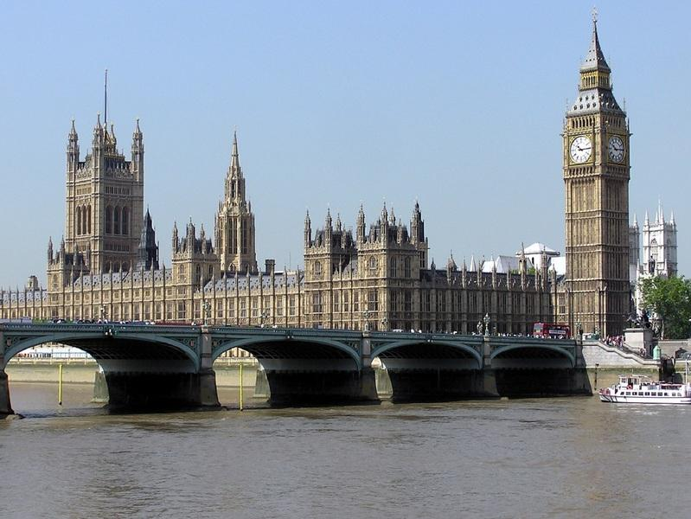

The regular PUBlic Affairs round-up returns with the Campaigns and Communications team’s latest updates on CAMRA’s campaigning across Westminster, devolved parliaments and local government.   Hollywood actor Rupert Everett joined the Campaign, attracting local and national media coverage, and is volunteering at his local, the Swan in Enford, to help keep it open.   As well as backing the Craft Beer Channel’s petition to get cask beer UNESCO heritage status, closing 1 October, CAMRA is supporting the Great British Pub Crawl’s petition to protect UK pubs, closing 8 October.     Westminster  Pubs Code for England and Wales The UK government is carrying out the Third Statutory Review and Post-Implementations Review of the Pubs Code and Adjudicator for England and Wales.   The team has made an official submission, offering recommendations for the improvements to the code and adjudicator.   Prior to this, a template email e-lobby was set up so our members could respond to the government’s consultation by asking them to improve the Pub’s Code for licensees and pubgoers. Almost 2,500 responses were submitted.  CAMRA is waiting for the Department for Business and Trade to respond with next steps.   Drink-drive limits [England and Wales] Suggestions that the UK government is considering reducing drink-driving limits have been made by the media.   Decisions will be part of a Road Safety Action Plan which is expected to be published in Autumn.     Welsh Government and Senedd Cymru  Deposit Return Scheme Last year the Welsh government announced it would introduce a Deposit Return Scheme on drinks containers later than England, Scotland and NI’s planned implementation.  A consultation on its plans for the scheme has now been published.  Unlike the scheme in England, Scotland and Northern Ireland, Wales will include glass containers, and possibly reusable and refillable container requirements along with deposits on single-use containers.  The Campaigns and Communications team will draft an official response on the need for inter-operability between the two schemes, while emphasising that independent businesses which stop selling into the Welsh market should pay fair costs on labelling and administrative requirements.  The consultation is available until 10 November.   Minimum unit pricing A consultation on minimum unit pricing has been opened by the Welsh government.  This will look at its policy, whether it should continue and at what level the minimum unit price should be, which is currently 50p per unit of alcohol.  The team will draft an official response to the consultation before it closes on 29 September.      Northern Ireland Executive and Assembly   Northern Ireland Licensing Review The Independent Review to Liquor Licensing in Northern Ireland was carried out by the University of Stirling.  The minister for Communities was supposed to respond by 20 August but an update from civil servants on 29 August said: “Work on the departmental response to the report on the Independent Review of the Liquor Licensing System, including the surrender principle, and its recommendations, is ongoing.”  Northern Ireland statutory responsible retailing code The Department for Communities has agreed The Responsible Promotion and Retail Sale and Supply of Alcohol to Consumers in Northern Ireland will become the improved statutory code, coming into effect from 1 January 2026.   Originally produced to outline basic standards of people involved in promoting and retail serving of alcohol in both the on and off trades in NI, the code stops this from being done irresponsibly.  This new fourth-edition statutory responsible retailing code will be made and managed by the Responsible Retailing Code Joint Industry Working Group, made up of Hospitality Ulster, NI Federation of Clubs, NI Hotels Federation, NI Retail Consortium and Retail NI.