CAMRA celebrates Cask Ale Week

19/09/2025 by WB Reporter

Campaign

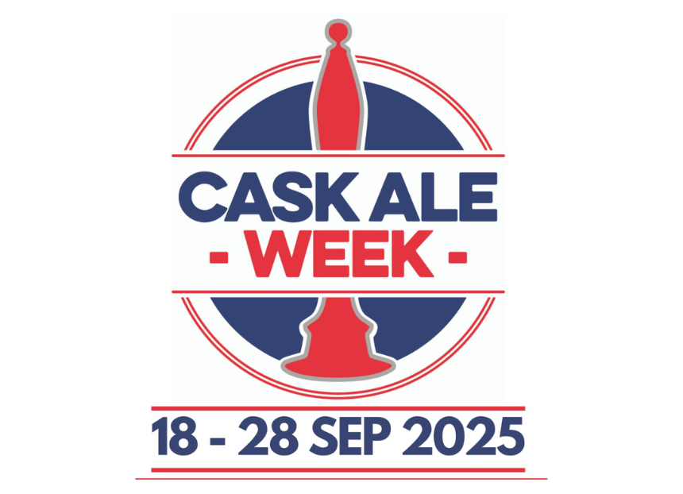

With the return of Cask Ale Week, CAMRA is urging everyone to back independent brewers and support their local pubs, social clubs and taprooms over the next 10 days.  Cask Marque’s annual initiative takes place 18-28 September with the aim of promoting cask beer and the venues which serve it. Cask Ale Week encourages pubs and breweries to host events from tap takeovers and tutored tastings to brewery tours and pub quizzes to celebrate this historic brewing and dispense method.  Throughout Cask Ale Week, there are several CAMRA festivals to enjoy, including: York Beer and Cider Festival, 17-20 September; Booze on the Ouse Beer and Cider Festival, 18-20 September; and St Albans Beer and Cider Festival, 24-27 September. Members are also encouraged to organise and upload their events to CAMRA’s events webpage.  New cask focussed content will be published on CAMRA’s educational Learn and Discover platform over Cask Ale Week, with the first of many new articles being Common ground: Can there be a relationship between cask beer and sparkling wine? by award-winning drinks writer Rachel Hendry. In her latest piece, Rachel explores the unexpected links and similarities between the two drinks.  A series of video shorts is also being published throughout Cask Ale Week, linking to the Learn and Discover’s new beer styles page, which features almost 50 different styles of beer, from oyster stout to west coast IPA. So far, beer writers Emma Inch and Jonny Garrett have run through the history of both the mild and New England IPA styles, describing the typical flavour profiles, aromas and ingredients, with many more coming soon.  CAMRA is using Cask Ale Week to highlight the ongoing Craft Beer Channel petition to see the production and serving of cask recognised as Intangible Cultural Heritage. At 100,000 signatures, this petition will be considered for debate in parliament. CAMRA wants cask to receive the protection it deserves from the UK government and UNESCO.   Sign the petition here.  From 16 September to 26 October, CAMRA members will receive an increased 25 per cent discount on all cask beers at participating Greene King pubs, more than double the usual 10 per cent. Simply show a valid CAMRA membership card when ordering at the bar to redeem this exclusive benefit. Find participating pubs here.  CAMRA chairman Ash Corbett-Collins said: “Cask Ale Week is the perfect chance to head down to your local and celebrate a great British pint of cask! The UK has some amazing brewers, and pubgoers should seek out locally produced beers.  “However, independent brewers struggle to compete against global brewers who have a stranglehold on the market, leaving little room for local producers to get their drinks behind the bar.   “Government must improve access to market for independent brewers to not only improve consumer choice at the bar but give independents a fighting chance against the corporations that dominate the trade.”   To find out more, visit caskaleweek.co.uk