York fest launch for low-alcohol beer push

18/09/2025 by Timothy Hampson

Industry

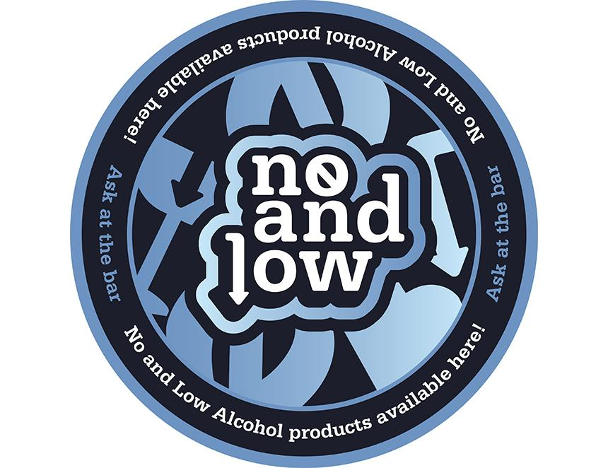

University of York researchers are behind a project to get more no-and-low alcohol beers in pubs across York and North Yorkshire. Launched at the CAMRA beer festival in York, researchers from the University’s School for Business and Society have developed a no-and-low alcohol (NoLo) guide with the City of York Council to help publicans understand how and why to offer alcohol-free options. The project includes the development of free point-of-sale (POS) materials designed in collaboration with York St John University student Sam Armstrong which build on the team’s work showing the need to make NoLo more visible in hospitality venues.   The project is part of an initial pilot study to see if the POS material helps to encourage further sale of NoLo drinks in venues across the city. The team will be evaluating the effectiveness of the materials through questionnaires with publicans. University of York lecturer Dr Nadine Waehning said: “The CAMRA beer festival may seem an unusual place to kickstart this project, but we have had a surprisingly positive response from publicans. “NoLo drinks are becoming more and more popular and publicans want to reflect the needs and tastes of their consumers. “Our research explores how NoLo products can be used to support more mindful drinking habits without harming pubs or the wider drinks industry. “Our research shows that NoLo drinks could support public health goals without financial downsides for pubs. This project provides practical guidance for venues and contributes valuable evidence to inform local and national alcohol policies. Co-project lead, professor Victoria Wells, professor of Sustainable Management in the School for Business and Society, said: “With more consumers looking for no-and-low alcohol products it’s great to be able to launch a guide and materials that can help them be more visible and accessible. We hope publicans will find the materials useful and effective. “We believe this collaboration marks an important step in encouraging inclusivity and choice within licensed premises.” Two York landlords worked on the guide and welcomed the initiative. Rook and Gaskill owner Paul Marshall said: “Adding a good quality no-and-low alcohol to our portfolio of beers has added a new level of experience to meet all our customers’ needs." Paul Crossman, owner of the Slip Inn and Swan, said: “Low-and-no drinks are an increasingly important option for pubs and bars as drinking habits evolve in the modern world. The quality and range of drinks on offer has improved greatly in response and we are able to access and stock a really interesting range of excellent independent options as a result.” Other research finds the number of new UK alcohol-free drinks brands jump as health and generational shifts redefine drinking habits. Many young people in Generation Z are choosing non-alcoholic options to align more with their healthy lifestyles spurred on by celebrity influencers such as Spiderman actor Tom Holland. The UK’s growing diversity also means many consumers abstain from alcohol for cultural or religious reasons. These lifestyle and demographic shifts are increasing demand for alcohol-free beers and ciders. People often choose non-alcoholic beers and ciders, as opposed to standard soft drinks, as they allow them to socialise with others who are drinking alcohol without feeling excluded. Mathys and Squire head of trademarks Claire Breheny said “The surge in trademarks for alcohol-free drinks underlines how quickly businesses are responding to the shift in consumer priorities. “By drinking less alcohol, the younger generation are redefining the R&D and marketing spend of the drinks industry. You can see the impact of that in any supermarket. Companies that fail to innovate in this emerging alcohol-free space fear missing out on one of the fastest-growing areas of the industry. “Leading brewers such as Heineken, Carlsberg, and Guinness have all launched 0.0 per cent ranges. “Alcohol-free drinks give these brewers access to prime-time advertising and sports sponsorships that are off limits to alcoholic products under current advertising rules. “Retailers and hospitality venues have responded to the surge by expanding shelf space and boosting visibility for alcohol-free products in stores, bars and restaurants.”