Planning bulletin - September

17/09/2025 by Paul Ainsworth

Campaign

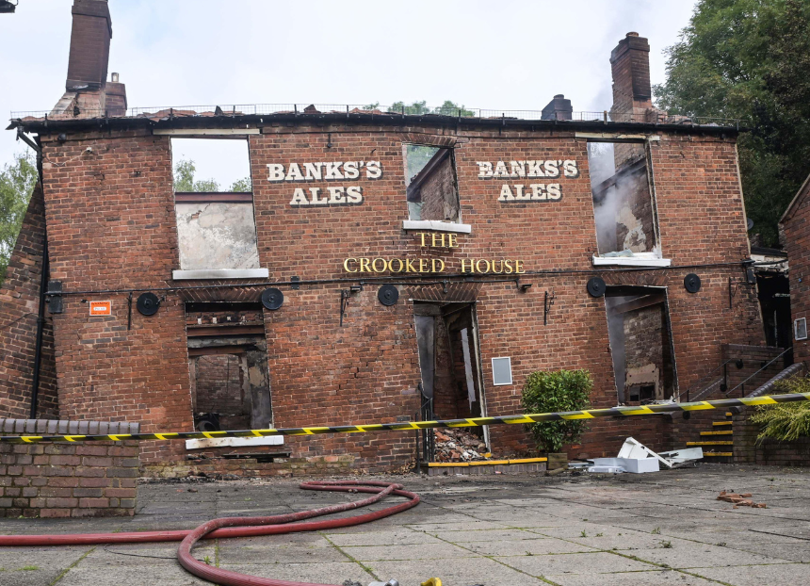

This bulletin is a new What’s Brewing series sharing information and advice about pub and club planning. Current position In recent times, the planning regime has become more protective of community facilities like pubs. The National Planning Policy Framework, first published in 2012, requires local planning authorities (LPAs) to guard against the unnecessary loss of valued facilities and services such as pubs. In England since 2017, planning permission has been needed for any change of use to, or demolition of, a pub. These changes have undoubtedly prevented many pubs being lost but further strengthening of legislation and policy, especially in Wales and Scotland, is still necessary. Crooked House It’s now more than two years since the tragedy of the Crooked House, Himley (above). The iconic pub was first badly damaged in a fire, and the remaining structure unlawfully demolished. Six people have been charged in connection with these events, but police investigations are still ongoing. The LPA issued an enforcement notice requiring a rebuild which was appealed, and the necessary inquiry will not take place until the police’s work is complete. The loss of the Crooked House highlighted the vulnerability of our pubs and has led for calls by CAMRA and others for planning protection to be enhanced. Wish list In the wake of the Crooked House, CAMRA compiled a campaigning strategy, including legislative changes it wants to see: introduce a legal definition of a pub for planning purposes. Currently, the boundaries between pubs, restaurants and hotels are unhelpfully blurred, as was demonstrated last year when Whitbread closed 115 pubs adjacent to Premier Inns, claiming they were restaurants make the demolition of a pub without planning permission in England illegal instead of unlawful. Illegal acts (violating specific laws) attract stronger penalties than unlawful ones (contradicting the rules) serving as a greater deterrent strengthen the enforcement powers available to LPAs and introduce brick-by-brick (i.e. total rebuild) orders for all demolitions, not just listed buildings removing permitted development rights in Wales and Scotland. CAMRA has discussed these aims with officials in the Ministry of Housing, Communities and Local Government. They requested detailed evidence on the problems caused by lax enforcement and lack of a pub definition, which has been supplied. In July, CAMRA met with under secretary of state Alex Norris MP at the ministry to discuss the Community Right to Buy proposals and went through the planning wish list. CAMRA is now trying to arrange a meeting with his colleague planning minister Matthew Pennycook MP. Pubs in new developments It’s longstanding CAMRA policy for it to be a requirement that all major housing developments include a pub as a community facility. This was mentioned at the meeting with Alex Norris and CAMRA was asked to produce evidence of non-provision. Branches are being asked to supply relevant information via the survey here. Permitted development in Wales and Scotland In Wales and Scotland, pubs can be changed to other uses without the need for planning permission. If the pub building isn’t listed, or in a conservation area, it can also be demolished without consent. CAMRA continues to press both governments to bring planning permissions in line with England. Individual LPAs are, however, able to make Article 4 directions that withdraw specified permitted development rights, and CAMRA will write to all relevant LPAs, encouraging them to explore this option. Protecting historic pub exteriors The Pub Heritage Group works to promote and protect the UK’s most important historic pub interiors. Many pubs have interiors too greatly changed to meet the group’s criteria but have distinctive and attractive exteriors. The group accepts that more could and should be done to preserve exteriors that are architecturally important and has produced guidance on the matter here. Branches are asked to take action where appropriate. Planning advice Lots of campaigning advice and information is on the CAMRA website. Save Your Local Pub is a key document, with separate versions for England, Scotland and Wales, for anyone trying to resist threats to their local and advising them how to go about this. Information on the site will be of value to CAMRA branches and active volunteers, and has been summarised in the Pub Protection and Planning document, covering detailed advice issues such as: what to do if a pub stays shut how to challenge claims of non-viability in planning applications key issues emerging from planning appeals using and influencing local plans. If you would like further information on any of the issues connected with pubs and planning, contact CAMRA national planning policy adviser Paul Ainsworth at paul.ainsworth@camra.org.uk Photo: Alamy. Do not reshare.