New guide to Sheffield pubs goes on sale

16/09/2025 by Dave Pickersgill

Campaign

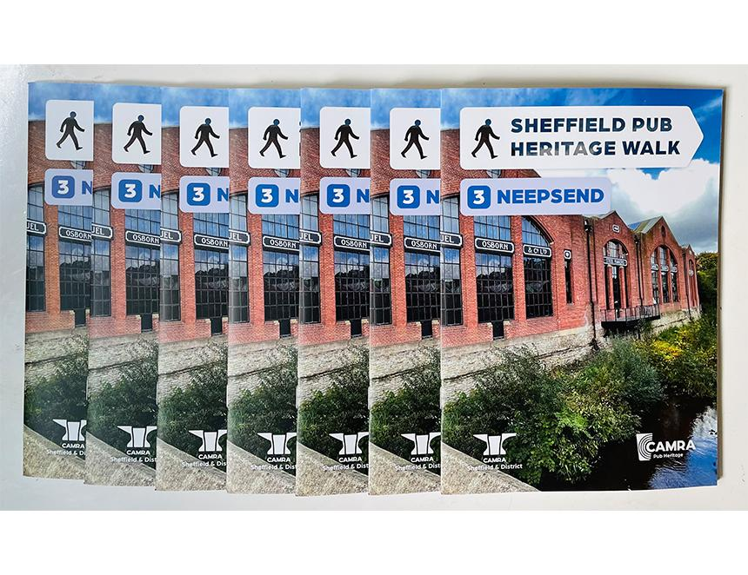

The third booklet in the Sheffield Pub Heritage Walk series has just been released and covers Neepsend. The new booklet includes a map, images and covers the area’s pubs and its history. The first booklet, produced for Members’ Weekend 2023, has sold out and there are few copies left of the second booklet covering Little Chicago. The series will continue with Kelham Island in 2026 and Riverside in 2027.  The formal launch will be at the Sheffield Steel City Beer Festival (15-18 October 2025) and, like its predecessors, the new booklet is 32 pages, A5, full-colour and costs £2.99 with a print-run of 1,000 copies. It is currently available from local stockists, including Abbeydale brewery, Beer Central, Biblioteka, Crow, Draughtsman (Doncaster Railway Station), Famous Sheffield Shop, Forest, Gardeners Rest, Hop Hideout, Kelham Island Books and Records, Millennium Galleries, Rhyme and Reason and St Mars of the Desert. For copies by post and retail enquiries, contact pubheritage@sheffield.camra.org.uk