Bright future for Little brewery as its celebrates fifth birthday

15/09/2025 by Dave Pickersgill

Industry

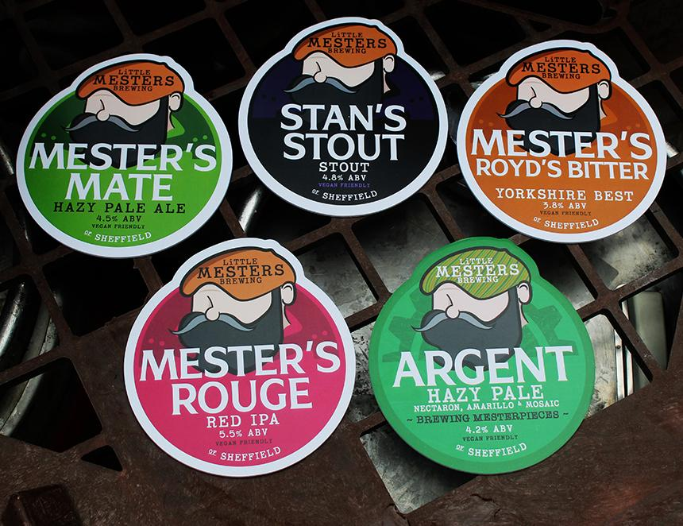

Sheffield-based Little Mesters first brewed in 2020 in the premises previously used by Mitchells Hop House and, as it celebrates its fifth birthday, it can look forward to benefitting from a new brewery and rebrand. In 2023, it opened its first bar, the Little Mesters Tap. Then, in late 2024, the brewery moved to Solpro Business Park in Attercliffe close to fellow brewer St Mars of the Desert.  The brewery is on the footprint of the 18th-century Royds brewery. This later became the Burton Weir brewery of Thomas Marrian and Co (1850-1904). In 1903, brothers F A and James Kelley acquired Marrian’s. By 1937, the Mesters' space was part of the Effingham Steelworks and Mills. Last November, the space was a derelict shell. Now, there is a mix of new and relocated brewery kits including some from Lost Industry, which closed in the summer of 2024. The five 1,000-litre fermenting vessels allow brewing to take place twice a week with each brew comprising 40 per cent cask, 40 keg and 20 cans. Head brewer is Sam Bennett, the driving force behind the highly rated Grizzly Grains brewery – a one-person operation (2020-24) which produced award-winning beers initially from his house in Walkley then from an industrial unit near Bramall Lane. He is assisted by Tom Naylor.  The move has also brought a rebrand involving design input from Nick Law (Emmanuales brewery). The logo has been tweaked but continues to include the little mester figure which advertises Little Mesters' beers. A little mester was a self-employed worker in the cutlery trade. Stan’s Stout (4.8 per cent) is a tribute to the last little mester, Stan Shaw (1926-2021). The brewery chose its name to honour those who helped put Sheffield on the map. The reputation of skilled work and producing quality products sums up how they feel about making beer. In addition to the stout, the core beer range includes Mester’s Royd’s Bitter (3.8 per cent), and two hazy pales: Argent (4.2 per cent) and Mester’s Mate (4.5 per cent). The red IPA, Mester’s Rouge (5 per cent) is named after a fine polishing paste, jewellers rouge, which is used for buffing knife blades. Other beer plans include a Kolsch, lager, a Christmas beer, and a cherry IPA. Co-owner Neil Adgie said: “The idea is to do beers that aren’t necessarily experimental but to perhaps do things that haven’t been done for a while. We want to do some fruit beers. We’ve got five really big cherry trees on site and we’ve got permission to harvest all of the cherries, so at some point it’s likely we’ll do a cherry IPA.” Pic: Dave Pickersgill