Cask beer earns place in ark

13/09/2025 by Laura Hadland

Industry

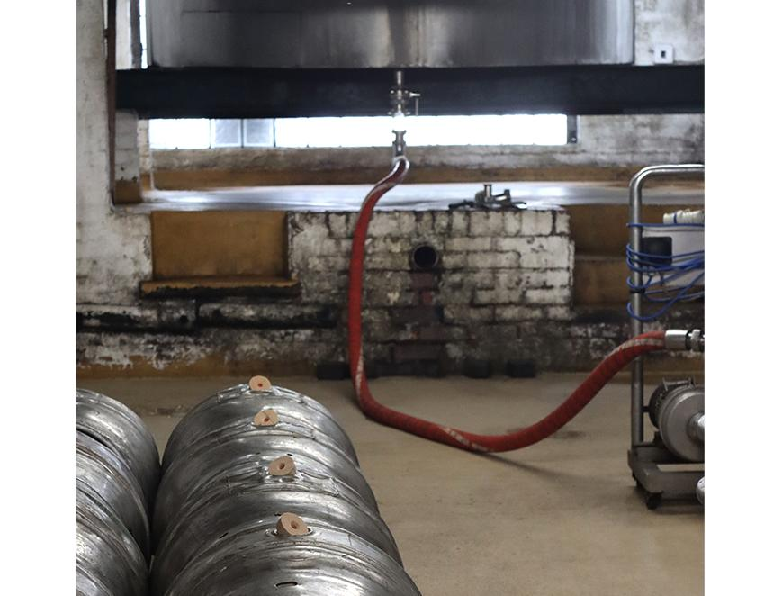

The Slow Food movement has recognised the significance of the United Kingdom’s cask beer tradition by making it a part of its Ark of Taste. Founded in Italy in 1986, Slow Food seeks to support food that is good, clean and fair for everyone on the planet. The Ark of Taste is a collection of “small-scale quality productions that belong to the cultures, history and traditions of the entire planet”. Cask joins the list of more than 6,600 unique ingredients, production methods and gastronomic traditions that are significant both to their communities and to the wider world. Cask beer, including the way it is made and served, was nominated for inclusion by Jared Ward-Brickett, chair of the Mid-Chilterns CAMRA branch. He was inspired to approach the Slow Food movement after seeing Jonny Garrett’s efforts to attain Intangible Cultural Heritage status for cask. Jared’s submission not only outlined the history and practicalities of cask beer production and service, but also clearly stated the current threats faced due to the economic pressures being felt in all corners of the UK beer industry. Co-chair of the Ludlow Marches Slow Food Group Tish Dockerty was one of the first to champion cask at Slow Food events, commissioning its first cask beer tasting in the Ludlow Food Festival’s 30-year history in 2023. “We’re thrilled to see cask ale accepted into the Slow Food Ark of Taste,” Tish said. “This is international recognition of how important this method of brewing is to British culture and the brewing industry.” As part of the Ark of Taste, cask beer will be highlighted and promoted by Slow Food, which will invite everyone to take direct action to preserve this important part of our shared cultural heritage.