Celebrate Cask Ale Week with Genevieve

12/09/2025 by Timothy Hampson

Industry

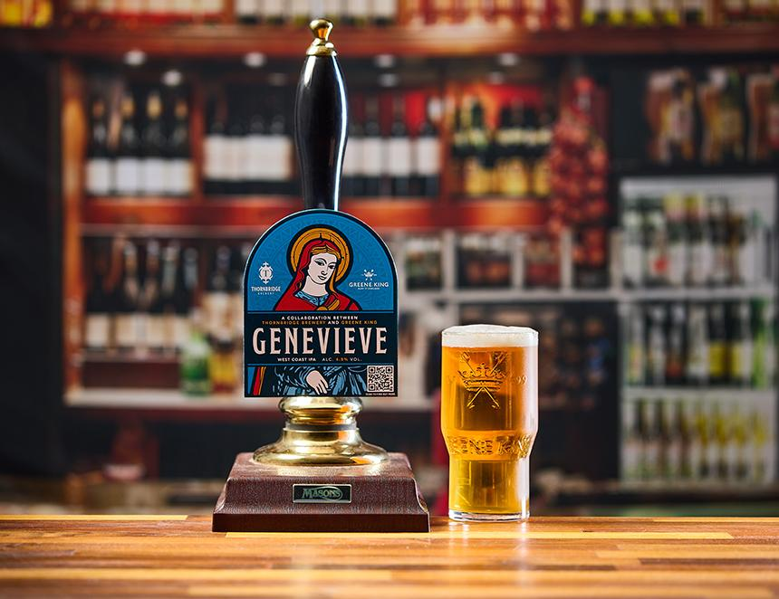

Genevieve is the first cask offspring of the brewing collaboration between Greene King and Thornbridge. Genevieve is a 4.5 per cent ABV West Coast IPA which combines pineapple and citrus flavours to create a hop-forward cask beer with a clean, crisp body. The beer will be available across September and October, including for Cask Ale Week. The recipe was jointly created at the Thornbridge brewery with trial and final brews at the Greene King brewery in Bury St Edmunds. The cask beer is dry hopped using two varieties Greene King has not used together before – Bravo and Sultana. Greene King technical brewer Alan Fulcher said: “When Thornbridge came up as a potential collaboration partner, we instantly said yes. We’re huge fans of their beers, and they share our commitment to cask and exploring the styles it offers. “Collaborating on a recipe that reflects the strengths of both breweries has been a fantastic experience, and I truly believe we’ve created a very special pint. As it’s Cask Ale Week at the end of the month, this is a great beer to have on the bar to celebrate.” Thornbridge brewery founder Simon Webster said: “We’re thrilled to be partnering with Greene King on Genevieve, our very first cask collaboration together. “As brewers with a shared passion for quality and heritage, it’s been fantastic to combine our expertise to create something truly special. “Genevieve is a celebration of cask ale at its finest — full of character, brewed for the season, and perfect for raising a pint to the start of autumn.” The beer is part of the Greene King Fresh Cask Releases calendar which includes 15 limited-edition beers celebrating seasons, sporting occasions, and collaborations with brewers.