Pub of the Year archives – 1990

11/09/2025 by George Robbins

Campaign

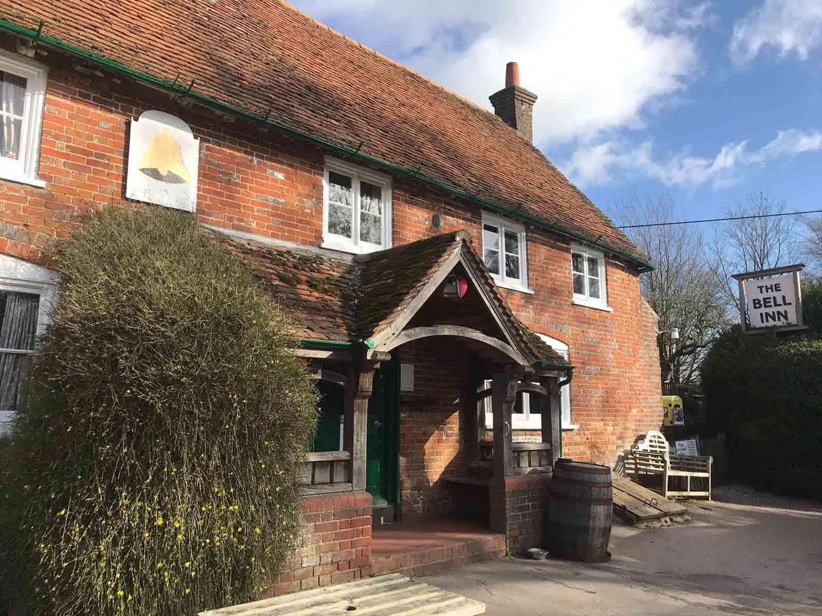

CAMRA’s Pub of the Year is the annual competition to find the very best local in the UK and in 1990 that was the Bell Inn in Aldworth. It would go on to repeat the success in 2019. It’s recently been named South Central Pub of the Year for 2025, so it could be on course to win a historic third time.   An historic gem with the only heritage pub interior in Berkshire, its name refers to bells which were part of the landowner's coat of arms. Evidence suggests an inn existed on the site as early as 1340 and the pub has been run by the Macaulay family for 250 years.   The pub’s interior is of outstanding national historic importance, having remained largely unchanged over the years, with a lot of Victorian furnishings. The ceilings are low, and the taps are enclosed in a small phone box sized cubical with serving hatches on all sides. A lot of the interior dates back to the 1930s and CAMRA’s Pub Heritage Group has given the pub the top Three Star status.  In 1990, Stephen Cox (then CAMRA head of communications) wrote in What’s Brewing: “There has been no brewery tart-up team pass through their doors, unless it is to have a quiet drink. The pub still feels lived in and loved, as a result. There is no electronic music, no TV and no gambling machines. Every time I’ve been there, the pub has been packed with people talking to each other and it seems to attract everyone in the area.”  Ian Macaulay (below), who died in 2010, had already been at the Bell Inn for 22 years when the pub won the first of its Pub of the Year awards and said that he wouldn’t be spoiled by success. He told local radio stations that he had “no idea” why he’d won. But this modesty really made it even more obvious why they had picked up the award. The pub had, and still has, a genuine welcoming atmosphere that can’t be replicated. The intimate and friendly design welcomes you in and has never lost its appeal. Ian’s memory is certainly alive and well in the Bell Inn to this day.

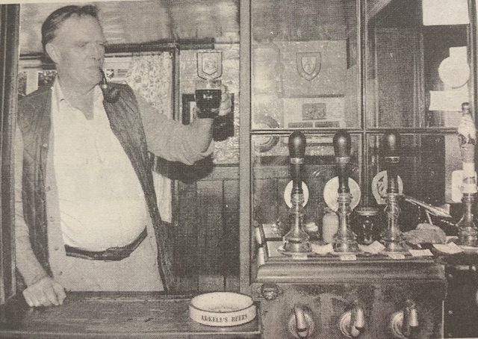

Runners up in 1990 were:   The Compasses in Littley Green, Essex, a picturesque, Victorian, country pub which regularly features in the Good Beer Guide and has won multiple local and regional CAMRA awards.

The Stalybridge Station Buffet is a Two Star heritage pub with an interior of special historic importance, being one of the few surviving licensed buffets on the English rail network from before the Second World War, it too is a regular in the Good Beer Guide.

The final runner up, the Rock in Glasshoughton, Yorkshire sadly closed its doors in 2021 and is now a café and restaurant.   You can pre-order the 2026 edition of the Good Beer Guide here.