Celtic celebration returns bigger and better

10/09/2025 by Timothy Hampson

Industry

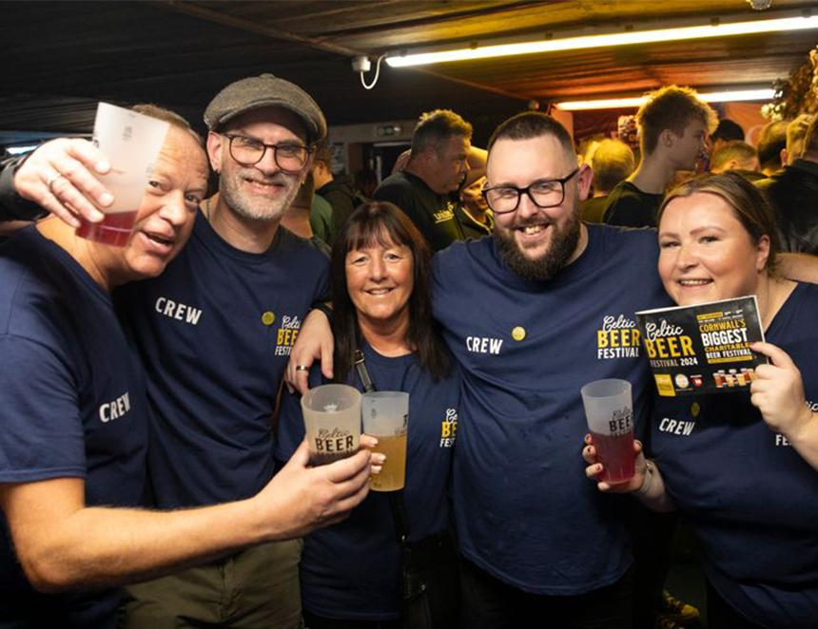

One of Cornwall’s biggest and most popular charity beer festivals is back and this year there’s even more to raise a glass to. St Austell has revealed the Celtic Beer Festival is returning on Saturday 22 November and, for the first time, festivalgoers can enjoy a special preview night on the Friday offering a behind-the-scenes experience at the historic brewery. For more than two decades, thousands have gathered at the brewery for a day of great beer, live music, and community spirit all in aid of charity. The 2025 festival will feature more than a hundred beers from breweries across the South West and further afield. All proceeds from ticket sales go directly to the St Austell Brewery Charitable Trust, which supports local charities, good causes, and individuals in need across the region. Last year’s festival raised more than £12,000 through the 1,300 visitors. The preview night on Friday 21 November offers a relaxed evening for enthusiasts to beat the crowds, sample exclusive brews, and meet the brewery’s talented brewing team. Early Bird Saturday tickets went on sale last week. All remaining tickets, including for Friday’s preview night, will be available from 11am on Friday 19 September. A limited number of tickets may be available on the door, but advance booking is recommended. To find out more and book your tickets visit: staustellbrewery.co.uk/celtic-beer-festival