Cask hero recognised

09/09/2025 by Timothy Hampson

Campaign

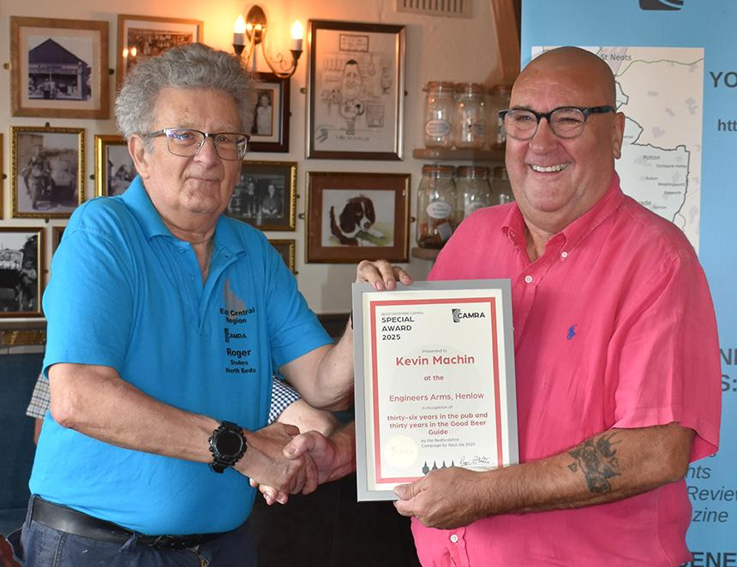

After 36 years of running Bedfordshire’s award-winning Engineers Arms – 30 of them in the Good Beer Guide – landlord Kevin Machin pulled his final pints earlier this month. It was the last night of a month-long “leaving party” for the popular former miner, who has won more CAMRA awards during that time than he can remember. The Engine – as it is known to locals in the village of Henlow – was one of four finalists from around the UK in the overall Pub of the Year contest in 2011. And it has frequently been voted Bedfordshire Pub of the Year, while this spring it was named East Bedfordshire branch’s Cider Pub of the Year. Kevin, 70, who ran the place with partner Sharon, said: “The Engineers has been more than a pub – over the years it has become an integral part of the village community. “The pub world is changing though now and it’s becoming harder. I’ve still got a good few years in me so I want to travel and enjoy myself while I still can.” CAMRA county co-ordinator Roger Stokes presented Kevin with a farewell gift of a miner’s lamp engraved with the pub’s logo and a certificate saying: “Thanks for 36 years of great beer, a wonderful atmosphere and unwavering support for CAMRA.” Branch chairman Barry “Baz” Price said: “It will be impossible to replace him. He’s done a superb job at this pub. He drinks real ale, is full of fun and cares about the community. “He is also a great front of house man – even if he does rarely pull a pint himself these days! But I don’t want to pump up his ego even more by saying much else!” As well as being popular with locals, the pub has also attracted some famous visitors from the nearby Champneys Henlow Spa. Football legend George Best used to sneak in and even signed up as president of the pub’s football team. And so too, a few years later, did Newcastle United and England star Paul Gascoigne. Vinny Jones once turned up with the whole Leeds United team, and the then Everton manager Howard Kendall used to pop in. For a while actress Julie Goodyear, who played Coronation Street landlady Bet Lynch, was also frequently spotted at the bar. Kevin, who used to work on the Communist Morning Star newspaper, once courted controversy with a specially brewed beer called KGB. But he innocently explained that it was the 1,000th cask beer he had served at the pub – and the initials, he said, merely stood for Kevin’s Grand Beer. He made headlines again with another beer called Stuff the Royal Wedding when King Charles married Camilla. Derby County fan Kevin, who was born in the Staffordshire brewing town of Burton on Trent, and partner Sharon will be retiring back to the Midlands. “It will be a wrench to leave,” he admitted. “But while I might not be serving beer anymore, I’ll still be drinking the stuff!” New owner Punch Taverns has promised to keep the same atmosphere. Head of acquisitions Kevin Cannons said: “We look forward to getting to know the local community and upholding the stellar reputation that Kevin, Sharon and the team have created locally. “I do not doubt that this fantastic pub will continue to thrive for many years to come.” Pictured: Roger Stokes, left, presents Kevin Machin with his certificate. Photo: Mel Draper