Actor pulls pints to save Swan

01/09/2025 by Timothy Hampson

Campaign

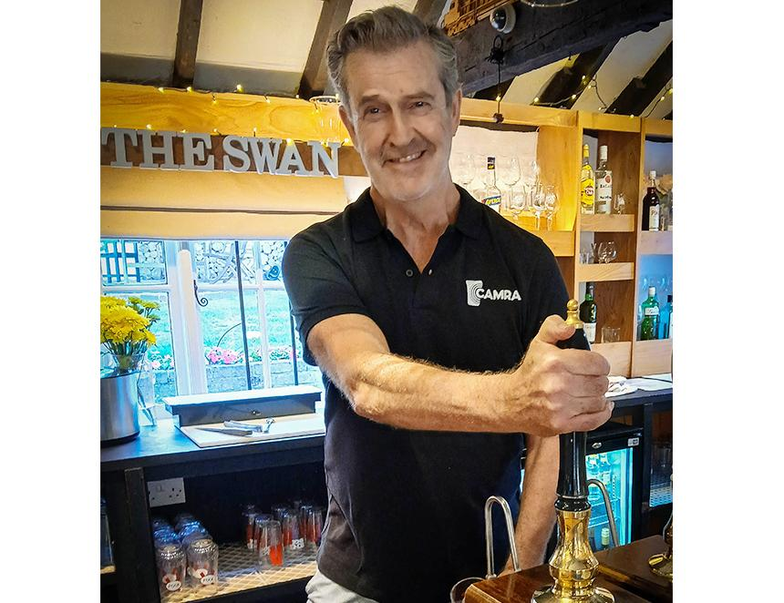

Actor and film star Rupert Everett has joined the Campaign and has been working behind the bar as part of a community effort to try to save the Swan, the only pub in the Wiltshire village of Enford. Rupert (above), who lives in the area, said: “There has been an amazing effort by the community to keep this pub open. Times are hard for rural pubs and this is the heart and hub of the village. I think that it is important to express my support. “I have recently joined CAMRA as I know real ale is the lifeblood of pubs both locally and nationally. Our small local breweries need our help, cask ale must survive – it is almost a uniquely British tradition.” Salisbury and South Wiltshire CAMRA branch secretary Steve Stringer said: “I am excited Rupert has chosen to support the Campaign. As a lover of cask ales, it is only natural that he wishes to join us and to see him behind the bar serving the locals, shows his solidarity with the community effort.” The Swan reopened in August after a massive effort by the community, which repaired and painted the Grade II-listed building, tidied the garden and then took a crash course in bar work. The pub, which has been on the site for 350 years, had been closed for a few weeks after the last licensee departed, but the village was not going to be left dry. Currently there are around 30 volunteers on the bar rota, including Rupert, in addition to the team maintaining the garden and fabric of the pub. The Swan is open from Thursday to Sunday for drinks and bar snacks, with cask beer offerings from local breweries. Rupert has starred in a number of Hollywood films, including the 1984 drama Another Country, alongside Julia Roberts in My Best Friend’s Wedding, and in the dual role of Camilla and Carnaby Fritton in the 2007 St Trinian’s remake. More recently he wrote, directed and starred in the Oscar Wilde biopic, The Happy Prince, and he also stars alongside Joaquin Phoenix in the Oscar-nominated 2023 film Napoleon.