Beer brats with Salcombe Pilsner

31/08/2025 by Christian Gott

Uncategorised

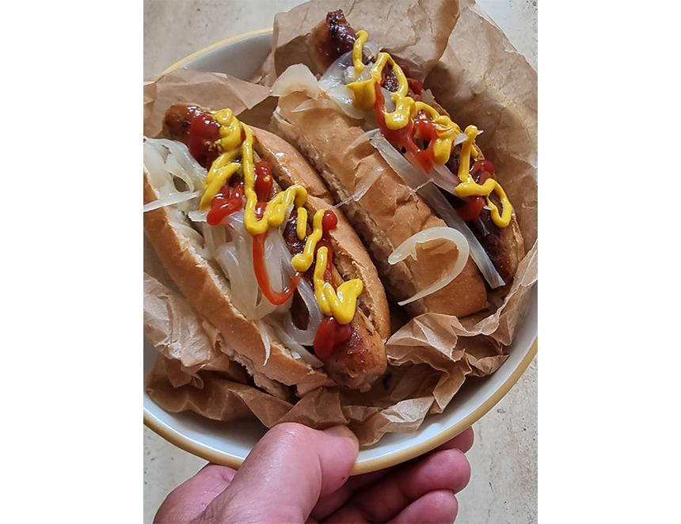

The playwright George Bernard Shaw once said that the US and UK are “two countries divided by a common language”. Take for example today’s recipe, in the UK a brat is a spoilt child whereas in America it is a type of sausage. You will hopefully be relieved to know that this recipe is for sausages cooked in beer and not drunken teenagers on the rampage. Beer brats originated in Wisconsin which was home to the largest German immigrant population in the US. Among the culinary traditions they bought with them were traditional sausages including bratwurst, a finely chopped pork or veal sausage, traditionally served with mustard and sauerkraut or potato salad. Beer brats are served at home during the Superbowl and on the Fourth of July and are a staple of tailgating. If you have ever been to a stadium before a big concert or sports game in America, you will have probably seen groups of people cooking and serving beer and drinks from the backs of their pickup trucks, often using specially converted BBQ rigs and bars. This is tailgating and the food served include bowls of chilli, sliders, and chicken wings as well as beer brats. Beer brats are bratwurst sausages cooked with beer and onions before being finished on the grill. I’m always a bit cautious of sausages cooked on a gas grill or barbecue. Sausages have a high fat content and often cause flame ups and smoking or, worse, burning. They can burst and may not even be thoroughly cooked, all of which is not particularly appetising. Poaching sausages in liquid first helps stop all of this, reducing the fat content and ensuring the sausage is cooked through. The sausages can also be prepared in advance. For this recipe I wanted a beer that was not going to overpower the flavour of the bratwursts. I settled on a lager and chose Salcombe brewery’s Pilsner (5.4 per cent ABV). Based in a brewery overlooking the estuary, Salcombe brewery’s beers are conditioned underground in an old reservoir. Established in 2016 the business now includes a state-of-the-art packing-and-distribution unit and its own borehole. Salcombe Pilsner is made from Czech and German hops that give a light citrus aroma, a pleasing, bittersweet flavour and crisp, dry finish. Bratwurst sausages can be flavoured with a mix of marjoram, nutmeg, caraway, coriander, ginger and lemon zest. They are available from most major supermarkets or specialist butchers, but you can use any herby flavoured sausage if you cannot get hold of them. If you fancy your own tailgating-style party and want to cook a large number of sausages, my top tip is to use a slow cooker. Simply add the ingredients and cook on low for six to seven hours. You can then use the slow cooker on low to keep the sausages warm until you grill or barbecue them. Beer brats with Salcombe Pilsner 10 bratwursts  2 large white onions 2x330ml cans Salcombe Pilsner 10 hot dog rolls, split open Mild American-style mustard Tomato ketchup Sea salt and freshly ground black pepper Peel the onions, cut in half and slice thinly. Place the onions and beer into a large heavy-bottomed pan with a lid. Season, cover and place on the heat and bring to a low boil. Cook for five minutes then add the bratwurst and return to a simmer for 10 minutes. Allow to cool for a few minutes before removing the sausages with a slotted spoon. Finish cooking the bratwurst on a preheated grill or barbecue, over a medium heat, turning frequently until brown. When cooked, drain the onion. Divide the onions between the hot dog rolls and add a cooked bratwurst. Top with tomato ketchup and mustard. You can add other toppings if you wish such as crispy shallots, bacon bits, melted cheese, salsa or relish.