Pump still pumping 50 years on as Beer Matters

31/08/2025 by Dave Pickersgill

Campaign

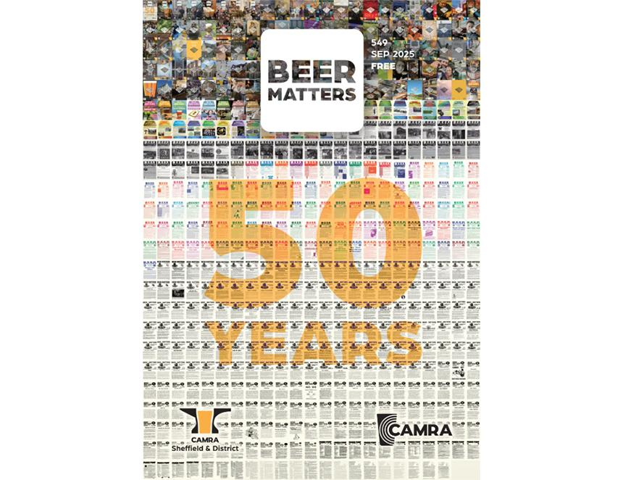

Half a century ago in the summer of 1974, Parish Pump joined the printed material which jostled for space in Sheffield’s pubs and clubs. This was the first edition of the Sheffield and District CAMRA magazine. It was a few sides of A4 stapled together – very different from today’s professionally produced, 32-page, full-colour Beer Matters. The intervening 50 years tell a tale of major changes in the Sheffield beer and pub scene, of large breweries closing, smaller producers taking their place and Sheffield becoming the cask beer capital of the world. Over almost 600 editions of the free magazine has included month-by-month reporting of these many changes. Parish Pump No 2 (6 September 1975) mentions: “At least 25 of the 61 pubs in central Sheffield sell real ale although one’s choice is limited to our local Big Three.” At that time, Sheffield had four large, long-established breweries; Stones Cannon brewery (established 1865), Wards Sheaf (1896), Whitbread Exchange (1851) and the often-forgotten Hope brewery on Claywheels Lane (1939). None of these remain, however, the city now has 17 breweries. The oldest is Abbeydale, now an employee-owned trust, which celebrates its 30th anniversary next year. In 1995, when Abbeydale started, no-one would have predicted that the 2025 Sheffield beer census would count almost 400 cask beers available on a single day: mostly on handpump. From edition 33 (September 1978) the format became A5 and the name changed to Beer Matters. As explained at the time: “This month your local newsletter has a new name and format. The former is an attempt to get rid of the ecclesiastical connotations of the old name Parish Pump: the latter is in order to make the publication more convenient to handle and easier to read. We hope that you agree that an improvement has been made in both these respects.” Over the years quality has improved: from four typed, stapled A4 sheets to a stapled A5 booklet to glossy publications and today’s full-colour publication. The 1980s booklets required a Beer Matters stapling social to put together the four A4 sheets (16 pages) in the correct order. I recall attending these monthly meetings in the Sheaf View, Bramall Lane. Here, lots of paper was delivered from the printer and large staplers were put to good effect. Since then, the branch has aimed to produce 11 issues annually - monthly with a winter double issue. Issue 500 was in September 2019. There has also been the occasional hiatus, for example, Covid saw a gap from April 2020 until a return in September 2021. Local CAMRA meetings were the original information conduit to the editor. Today, in addition to the various meetings, internet resources are extensively used. Over the years, Beer Matters editions have included memorable stories: 11 (1976): includes the news that a beer exhibition venue has been found. This was the second Sheffield Beer Festival, and next year will see the 50th 190 (November 1991): 21 Not Out – CAMRA was 21 years old 281 (August 1999): Wards laid to Rest, the closure of Wards brewery 403 (November 2010): the first edition with full-colour throughout 500 (September 2019): includes several retrospective contributions 520 (February 2023): Tom and Barbara retire after over 37 years at Fagan’s. Beer Matters has had hundreds of contributors and many editors. In addition to these editors, thanks also need to be given to Robin Lunnon for linking the magazine to the branch website and bringing design into the digital era. Thanks to all who have contributed over the last 50 years. Let’s all drink to the next 50! Sheffield and District CAMRA magazine editors: Parish Pump 1-14: Colin Walker, Tony Scholes 15-27: John Kidd, Geoff Jenkins 28-32: Geoff Jenkins, David Grey Beer Matters 33-40: Geoff Jenkins, David Grey 41-54: David Grey, Terry Fellows 55: Terry Fellows, Norman Spalding 56: Terry Fellows 57-59: Terry Fellows, Mike and Joanne Taylor 60: Terry Fellows 61-64: Terry Fellows, Carole Ware 65-79: Carole Ware 80-112: Iain Colquhoun 113-148: Adrian Staton 149-175: Lis Colquhoun (Lis Hensman from 155)  176-220: Mike Hensman 221-237: Adrian Staton 238-265: David Staves 266-276: Richard Hough, Kathryn Page 277-282: David Staves 283-284: Linda Hutton 285-292: Leuan Willis 293-295: Tim Stillman 296-330: Paul Goddard 331-474: Andy Cullen 475-495: Dom Nelson 496-to date: Andy Cullen