There's nothing like a South Pacific beer...

30/08/2025 by John Westlake

Uncategorised

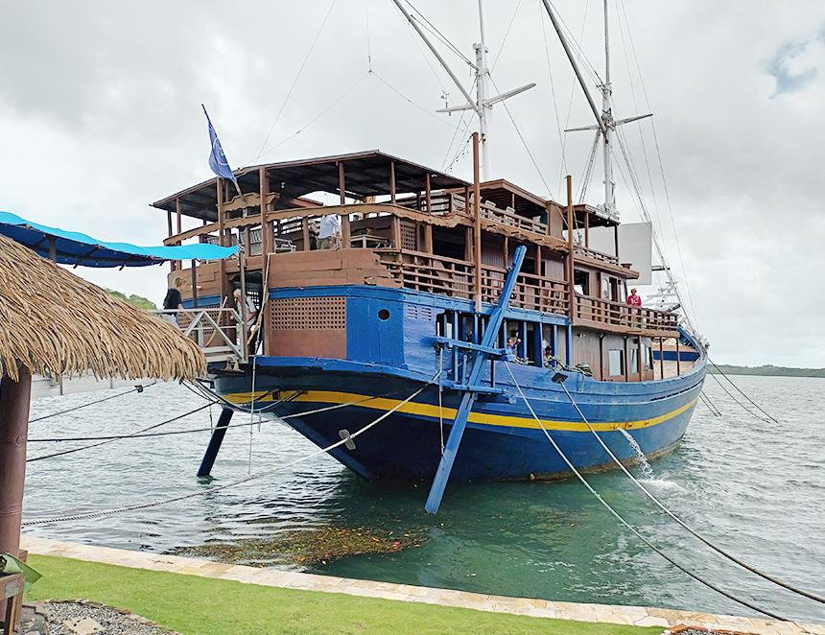

Lost in the vast, blue expanse of the Pacific Ocean lies the Federated States of Micronesia. Sandwiched between the independent nation of Palau and the distant Marshall Islands, it comprises a host of beautiful coral atolls, among which is the fascinating island of Yap, one of the States and famous for its extraordinary stone money (rai or fei stones) and a brewery (above) bearing the same name. It is located inside the modest Manta Ray Bay Resort, which is also home to Yap Divers, where owner, Bill Acker, wanted to provide something different for his diving customers. The owner of Cook Islands Divers, Greg Wilson, had been brewing his own beer since 1978 and also happened to be a good friend of Bill’s, so it is easy to guess what happened next. In 1999, Greg visited Yap again and this time brought with him all the necessary kit and ingredients for Bill to begin brewing at home, much to his wife’s disapproval, and thus began the story of the Stone Money brewery. As Bill’s confidence grew, Ian Ward of London-based Brewvisions was hired to help instal a microbrewery on the S/V Mnuw (sea hawk in the local Yapese language), a replica galleon permanently attached to the rear of the hotel, which hosts a popular restaurant on the main deck, together with an open air bar above. Meanwhile, Fredy Gull, an experienced brewmaster from Zurich was hired to take charge of the operation. As the years passed, the brewery outgrew its shipboard location and a new, larger microbrewery was created inside the lobby of the adjacent hotel, where Fredy still holds the reins despite recently celebrating his 80th birthday. Proof, perhaps, of the healthier aspects of his pure, unadulterated beers! Fortunately, I am assured he has someone waiting in the wings to take over when the time comes. Just two beers are produced, some of which is put into typically continental, flip-top bottles for use by diners in the restaurant, but they are not allowed to be taken away due to the high importation costs. The bulk of the output, however, is served on tap in the top deck bar, where two steel fonts are topped by British ceramic pump handles. Both beers are brewed in accordance with the German beer purity laws of 1516 and neither are filtered or pasteurised, while the same compressed air as used for the diving tanks is employed to raise the beers from keg to bar. The result is two stunningly good, fizz-free beers at 5 per cent ABV that were a most unexpected but hugely welcome find in this remote part of the world. Manta Gold they describe as “a true European lager”, although I felt it bordered on being a very refreshing, dry pale ale. Fashioned from Moravian malt, with a small amount of rice flakes for colouring, it is seasoned with German Hallertau Mittelfrueh and Czech Saaz hops, after which it is conditioned at 6°C for up to four months. This beer deservedly won a silver medal at the 2020 Concours International de Lyon in the Helles poured category. Hammerhead Amber, on the other hand, is crafted with Harrington and Triumph malts combined with a little crystal malt to darken the brew and add a slightly caramelised flavour. Northern Brewer hops for bittering together with Cascade, which impart enjoyably floral, citrusy notes, combine to produce a chestnut-hued brew that skilfully combines dark lager characteristics with a seemingly West-Coast influence. Yap’s delectable beers almost justify a journey halfway round the globe. And what’s more, you don’t have to pay for them with stone money!