Time to plan your autumn festival visit

29/08/2025 by George Robbins

Campaign

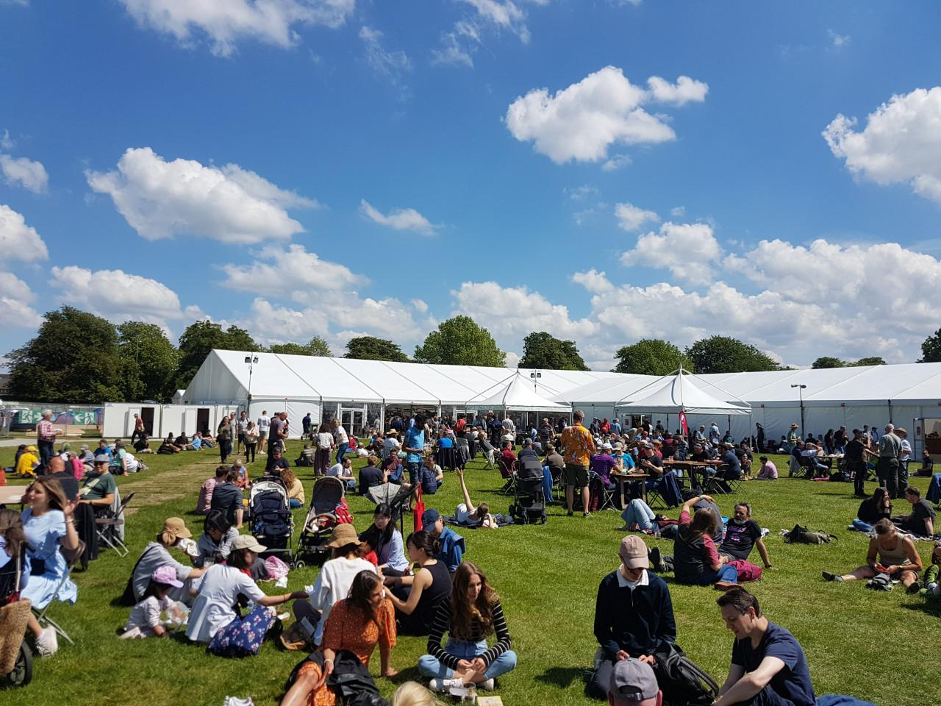

As we head into autumn, make the most of it with a festival trip or two. Just pick from the list below. To see all upcoming CAMRA events, visit the events webpage.    Barnsley Beer Festival, 28-30 August St Peter Church, Brinkman Street, Barnsley, S70 1JQ alexandrawalton.wixsite.com/mysite   Bridgnorth Beer Festival, 28-30 August Bridgnorth Rugby Club, Bandon Lane, Bridgnorth, WV15 5AD bridgnorth.camra.org.uk/bridgnorth-beer-festival/   Harbury Beer and Cider Festival, 29-30 August Harbury Village Hall, South Parade, near Leamington Spa, CV33 9JE how.camra.org.uk/   CAMRA Bar at Faversham Hop Festival, 30-31 August  East Street, Faversham, Kent, ME13 8AF  kent.camra.org.uk/viewnode.php?id=258408   Derby Heritage Beer Festival, 3-6 September Museum of Making, Derby, DE1 3AF derbymuseums.org/event/derby-heritage-beer-festival   31st Tamworth Beer Festival, 4-6 September Assembly Rooms, Corporation Street, Tamworth, B79 7DN lst.camra.org.uk/beerfestival.htm   Basingstoke Beer Festival, 5-7 September Basingstoke Sports and Social Club, Fairfields Road, Basingstoke, RG21 3DR hantsnorth.camra.org.uk/viewnode.php?id=201850   Wimbledon Beer Festival, 5-7 September Unit 8, College Fields, Wimbledon, SW19 2PT wimbledonbrewery.com/collections/shop-all   East Malling Beer and Cider Festival, 6 September East Malling Research Centre, New Road, ME19 6BJ mmk.camra.org.uk/festival   Chappel Beer Festival, 9-13 September East Anglian Railway Museum, Chappel & Wakes Colne Station, Station Road, CO6 2DS chappelbeerfestival.org.uk   18th Moreton Beer and Cider Festival, 12-13 September Moreton in Marsh Cricket Club, Moreton in Marsh, Gloucestershire, GL56 9QA northcotswoldcamra.org.uk/Festival18.htm   Late Summer Beer and Cider by the Sea, 12-14 September Western Lawns, King Edward Parade, Eastbourne, BN21 4EQ visiteastbournetickets.co.uk/beer-festivals   York Beer and Cider Festival, 17-20 September St Lawrence Parish Church, Lawrence Street, York, YO10 3WP yorkbeerfestival.uk   Booze on the Ouse Beer and Cider Festival, 18-20 September Comrades Club, Godmanchester, 58 Cambridge Street, Godmanchester, PE29 2AY hunts.camra.org.uk/festival   St Albans Beer and Cider Festival, 24-27 September St Peter's Street, St Albans, AL1 3LD stalbansbf.org.uk   Bedford Beer Festival, 1-4 October Bedford Corn Exchange, 13 St. Paul's Square, Bedford, MK40 1SL northbeds.camra.org.uk/viewnode.php?id=243327   Ayrshire Real Ale Festival, 2-4 October Municipal Buildings, South Beach, Troon, KA10 6EF ayrshirebeerfestival.co.uk   13th South Woodham Ferrers Beer and Cider Festival, 2-4 October South Woodham Ferrers Village Hall Social Club, 25 Hullbridge Road, CM3 5PL maldonanddengiecamra.org.uk/swfbeerfestival   Carmarthenshire Real Ale and Cider Festival, 2-4 October St Peter’s Civic Hall, 1 Nott Square, Carmarthen, SA31 1PG carmarthenshire.camra.org.uk/index.php/carmarthenshire-beer-festival   18th Ascot Beer Festival, 3-4 October Ascot Racecourse, Ascot, SL5 7JX ascotbeerfest.org.uk   Weymouth Octoberfest Real Ale and Cider Festival, 3-4 October Weymouth Pavilion, Weymouth, DT4 8ED camrawdorset.org.uk/   Nottingham Robin Hood Beer and Cider Festival, 8-11 October Trent Bridge Cricket Ground, Radcliffe Road, West Bridgford, NG2 6AG nottinghambf.camra.org.uk/   Steel City Beer and Cider Festival, 15-18 October Kelham Island Museum, Alma Street, Sheffield, S3 8RY sheffield.camra.org.uk/festival   Carlisle Beer and Cider Festival, 23-25 October Station Hotel, Court Square, Carlisle, CA1 1QY solway.camra.org.uk/   Swindon Beer Festival, 23-25 October Steam Museum, Firefly Avenue, Swindon, SN2 2EY swindon.camra.org.uk/viewnode.php?id=23556   15th Gainsborough Beer Festival, 23-25 October Blues Club, Northolme, North Street, Gainsborough, DN21 2HU fenland.camra.org.uk/viewnode.php?id=5964   27th Worthing Beer and Cider Festival, 24-25 October Rooms, 44 Guildborne Centre, Worthing, BN1 1LZ aaa.camra.org.uk/wbf   Redhill Beer Festival, 30 October-1 November Merstham Village Hall, Station Road North, Merstham, RH1 3ED ems.camra.org.uk/festival   Alloa Real Ale and Cider Festival, 7-8 November Alloa Town Hall, Marshill, FK10 1AB facebook.com/events/1412826513278691   Newark Beer and Cider Festival, 21-22 November Newark Town Hall, Market Place, Newark-on-Trent, NG24 1DU newark.camra.org.uk/beer-festival/