Coventry brewery celebrates 10th birthday with expansion plans

28/08/2025 by Timothy Hampson

Industry

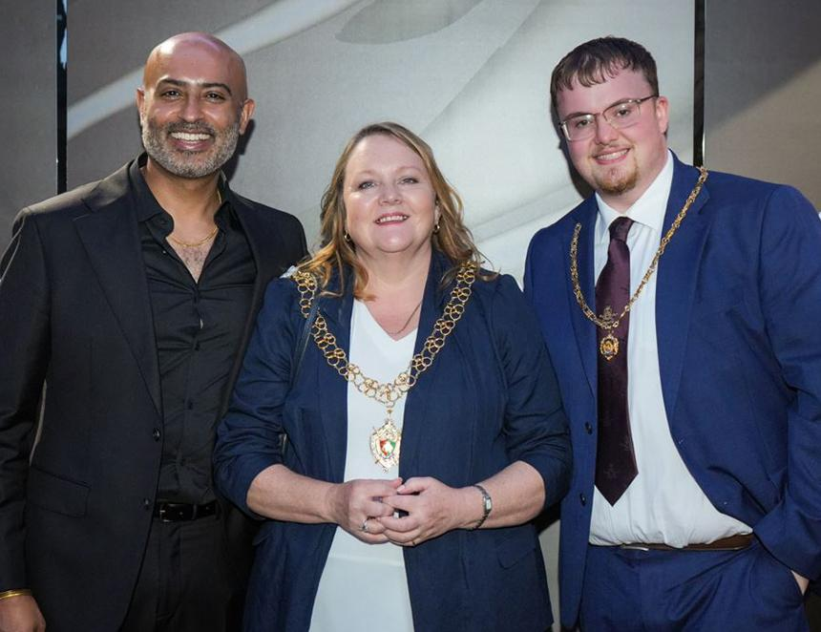

A thriving Coventry brewery raised a glass to toast its 10th anniversary as the company sets out plans for further growth. Dhillon’s brewery has gone from strength to strength since entrepreneur Dal Dhillon made his business dream a reality in 2015. The brewery now employs more than 70 staff and expects to create a further 50 new jobs over the next year. Its head office has expanded and the business now runs three venues – Dhillon’s brewery in Longford, Spire Bar and Sky Blue Tavern, both in Coventry city centre – as well as three sites within the Coventry Building Society Arena. A fourth venue is in the pipeline amid advanced plans to launch Elle’s Foodhall, a 7,000sqft venue at Coventry’s expanding train station that will feature local food vendors, barista coffee and a bar. Dozens of staff and supporters of the business, including the lord mayor of Coventry, Cllr Rachel Lancaster, gathered for a night of live music, cocktails, street food and even fire breathers to celebrate its milestone. Dhillon said: “It was great, and we were so proud, to welcome loyal patrons and partners to raise a glass to the past, present, and future of Dhillon's brewery at our anniversary celebration, as a little way of saying ‘thank you’ for all the support we've received. “Over the course of the last decade we have constantly been looking at opportunities for growth – whether that is through our range of beers, agreeing partnerships or opening new venues. “As the brewery celebrates its 10th birthday, we will be looking to take the business to the next level and the opportunity at Elle’s Foodhall is a major part of that strategy. “We’re really grateful to be working with the city on the Friargate 2 project and will be opening our doors at the end of the year. There are also other units opening outside of Coventry, with more details to follow early next year. “When I think back to starting the business and how far we have come, it has been an incredible journey. But one thing has been a constant throughout those years, and that’s the support of people in Coventry. “Our best-selling beers pay homage to the city that has embraced Dhillon’s brewery and we’re always looking at new ways to give back to the city; be that by employing local people or by supporting charities that do important work. “We’re excited about what the future holds for the brewery. Our aim is to put Coventry firmly on the hospitality and leisure map through the work we're doing nationally and internationally.” The brewery has produced close to 100 beers since it launched and has won more than 40 awards, including Pub of the Year, Independent Beer Awards, Craft Beer Producer of the Year Awards, and awards for its contribution to Coventry. Pictured from left: Dal Dhillon, Rachel Lancaster and the mayor’s consort Lawrie Lancaster