Carpenters carves cider niche

27/08/2025 by Timothy Hampson

Campaign

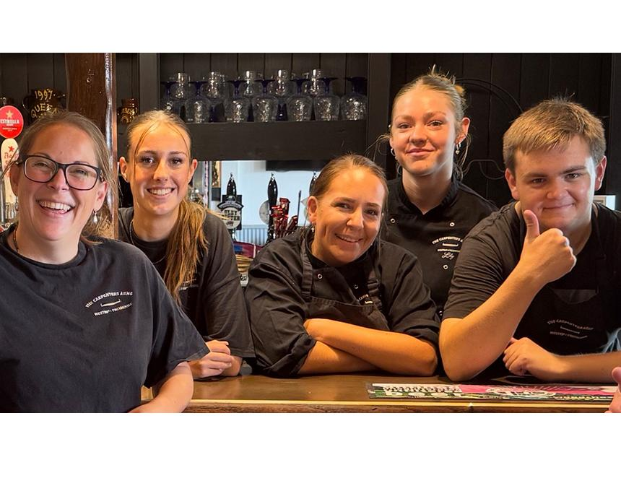

Is Gloucestershire the new home of cider? That’s the question being asked as the Carpenters Arms in Westrip, just outside Stroud, is named CAMRA’s West Central Regional Cider Pub of the Year 2025, triumphing over entries from traditional cider areas in Herefordshire. In a newly created CAMRA region that spans Gloucestershire, Herefordshire, Oxfordshire and Worcestershire, this is a significant moment for the county’s growing cider reputation. The Carpenters Arms, which serves an exclusively Gloucestershire-sourced range, has become a beacon for quality, community, and local pride with CAMRA judges highlighting its warm welcome, commitment to local producers, and exceptional cider quality. The pub, which sits on the Cotswold Way, is a favourite stop for thirsty walkers and locals alike. At its heart is landlady Sammy McKie, (pictured left above) who took over the pub just two weeks before the first lockdown in 2020. “This is more than just an award – it’s a real vote of confidence in everything we’ve built here,” Sam said. “To win against pubs in places like Herefordshire, which has such a deep cider heritage, is a huge boost for all our local producers and regulars. We’re really proud.” The Carpenters represents the Stroud area of CAMRA’s Mid-Gloucestershire branch, which also includes Gloucester, Cirencester, Dursley, and the Forest of Dean. Local winners are chosen by area, then branch, then county, before facing off at regional level with the Carpenters Arms now heading to the overall final. CAMRA’s cider recognition has grown significantly in recent years, reflecting a renewed national interest in real cider and perry. Pubs are judged not just on cider quality, but also their promotion of it, cleanliness, community focus, staff knowledge and service, and support for CAMRA’s wider aims. Locals and cider lovers are warmly invited to raise a glass at the official award presentation on Friday 12 September at the pub.