Community spirit thriving at heritage winner

26/08/2025 by WB Reporter

Campaign

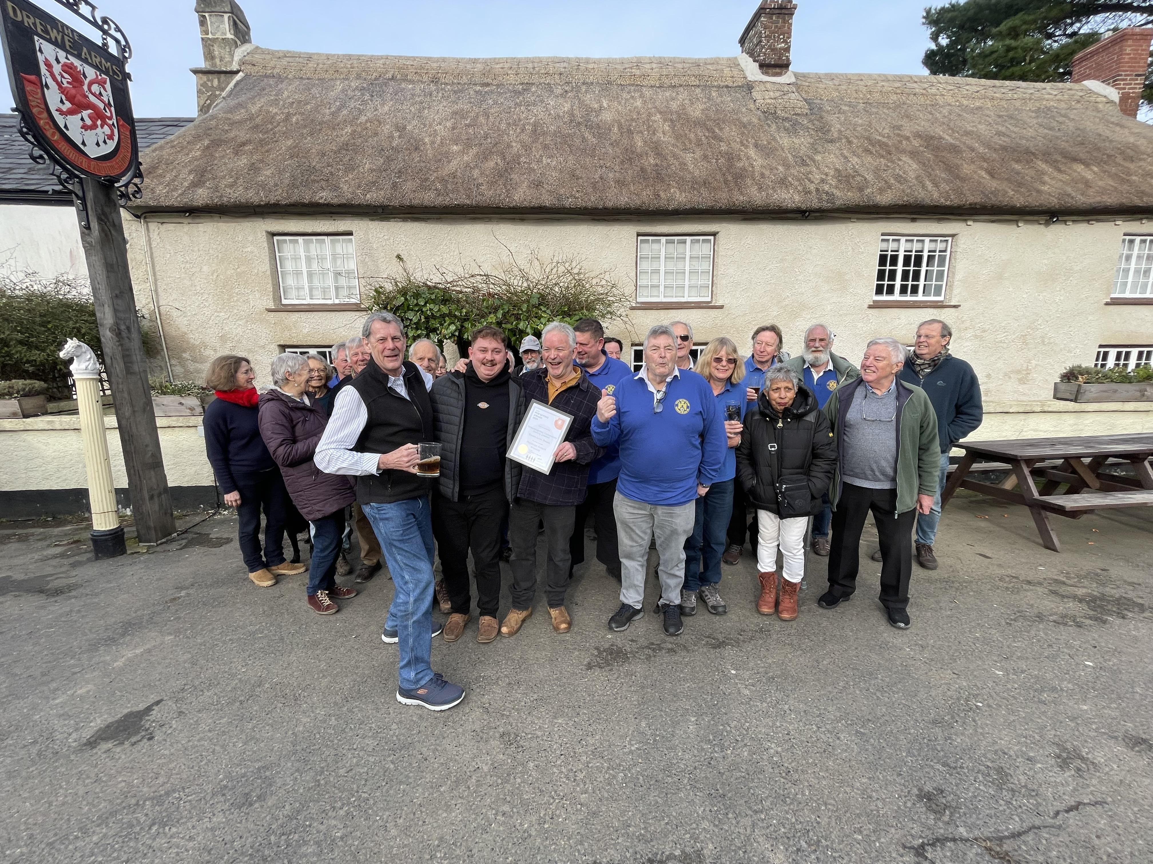

With nominations for the Pub Saving Awards now open, What’s Brewing caught up with the first Heritage Award winner, the Drewsteignton Benefit Society, to see how the Drewe Arms Community Pub (above) in Dartmoor, Devon has fared over the past year. Drewsteignton Benefit Society director Jane Martin said: “The CAMRA Heritage Award to the Drewe Arms Community Pub was a real boost to all involved in saving this Grade II\*-listed exceptional pub in Drewsteignton, on the edge of Dartmoor. “In 2022, the pub, shop and post office closed leaving villagers isolated. A few locals got together, held surveys, meetings and pop-up pub events followed by a successful Crowdfunder community share offer, enabling the purchase of the historic pub and its reopening. “The pub was already recognised by CAMRA as special. Its listing described the Drewe as ‘a legend in the annals of historic rural pubs’. It was also famed for the kindly hosting of Aunt Mabel, England’s longest-serving landlady. “The Drewe is now thriving again as the social centre of Drewsteignton and surrounding area. As a community pub, it does much more than serve drinks and simple, affordable food. There is a mixed programme of music and events to engage all ages in the Long Room behind the pub. All are welcome and there is accommodation for visitors, including in the stunning Church Cottage. “Since January, when CAMRA members visited to make the award, much has happened. On 17 March, a devastating fire destroyed the four National Trust cottages opposite the pub. Members of the team called the Fire Brigade, ensured the residents were safe and, liaising with the church and National Trust, helped to rescue and store as much as possible of their possessions. Locals worked all night in the pub with the landlord to provide tea and respite for the fire crews. Others continued the next day. Residents were accommodated in the Drewe’s Bunk Rooms until more permanent shelter could be found. The National Trust is planning reconstruction. “The next night, many gathered in the pub with musicians while the fire crews still worked. We knew then that the community business is now socially thriving. The village has found a common cause and pride in the community ownership of the Drewe. “We proudly display the certificate awarded by CAMRA, which represents recognition of success in revitalising a truly historic community asset.” The Heritage Award is open to all pubs on CAMRA’s National Inventory of Historic Pub Interiors, whatever their star grade. Nominate a heritage pub revitalisation project here.