Taste the difference for free during Cask Ale Week

26/08/2025 by Timothy Hampson

Industry

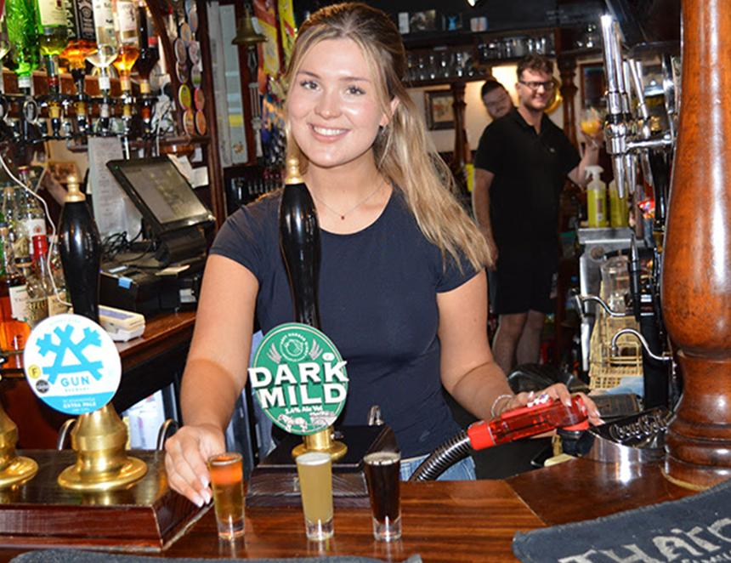

Pubs across the UK will be offering a million free try-before-you-buy beer tasters during Cask Ale Week in September this year. The unprecedented sampling campaign will see 10,000 pubs offer at least 100 freshly pulled samples of cask beer (above) throughout the week-long promotion, which runs 18-28 September. The aim is to tempt people back into the habit of visiting their local, as well as to support sales of cask beer, the UK's signature beer style. Samples will be offered in every style from light, hoppy pale ales and amber best bitters, to dark, smooth stouts including low-alcohol options. Customers at participating pubs can pick their style, enjoy a free taster, and hopefully go on to order a pint or two.   Head brewer at Suffolk brewer Adnams Fergus Fitzgerald said: “Free tasters will hopefully encourage many drinkers to enjoy a pint of real ale during Cask Ale Week, and make it one of their regular drinks. “If more people chose cask ale on just one more of their visits to the pub, it would make a big difference to the future prospects for our national drink – and to pubs, which are the only places to sell it. “Ironically, cask beer seems to be more appreciated globally than it is in Britain. Incoming tourists put a visit to a traditional pub to enjoy a pint of foaming cask ale close to the top of their ‘must-do’ list. Equally, many of the world’s top craft beer brewers cite British cask ale as their biggest influence. "However, pubs really need local customers in order to thrive. Cask Ale Week is an opportunity for drinkers to find the style they most enjoy and show their support for British pubs and British beer.” Many pubs will also be offering taster flights of beer during Cask Ale Week, giving customers the opportunity to try a combination of styles.