Brewing returns to Wiveliscombe

25/08/2025 by Timothy Hampson

Industry

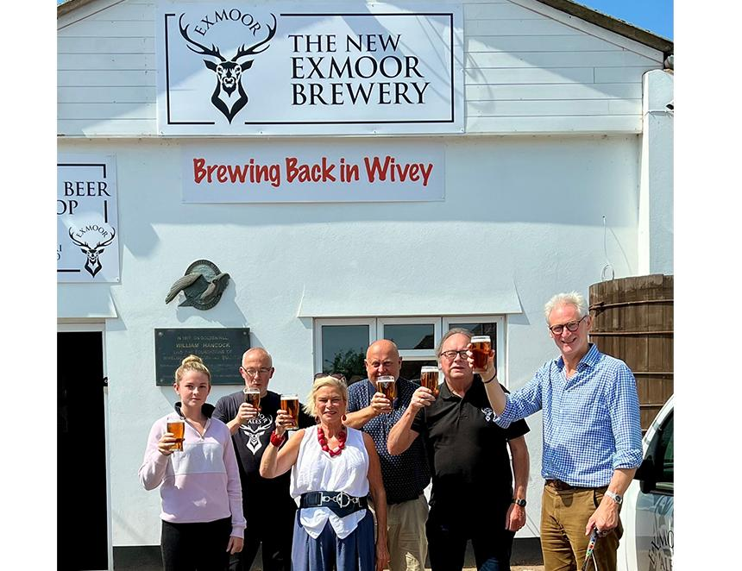

Brewing returns to Wiveliscombe, Somerset when the New Exmoor brewery’s first beer will roll off the line on the site of the former Cotleigh operation and raise money for the Jim Laker charitable trust. Laker was MD of Exmoor Ales and inspiration behind WestFest, Wiveliscombe’s beer and music festival. Exmoor Ales ceased brewing on the town’s Golden Hill site in April and began a collaboration with Surrey-based Hogs Back brewery. The partnership has seen Exmoor’s award-winning ales replicated at the Surrey brewer’s site, with Hogs Back continuing to brew beers including Exmoor Gold, Exmoor Ale, and Silver Stallion. The New Exmoor brewery will focus on specials such as Exmoor Beast and limited-edition beers brewed by former Cotleigh head brewer Shaun Vockins. Hogs Back will handle distribution into other areas and all off-trade customers and will invest in Exmoor Ales beers to introduce them to a broader audience. The collaboration with Hogs Back and opening of New Exmoor saves 10 jobs. It also opens up distribution opportunities for Exmoor, which is looking for a small group of brewer partners whose beers it can distribute in the West Country. Exmoor Drinks chairman Jonathan Price said: “We are beyond thrilled to be brewing back in Wivey, where we started brewing in 1979, in a new brewery proudly showing the Exmoor name and our iconic stag logo. “Deciding to close our brewing operation was done with a heavy heart, as the only response to insurmountable business challenges. “Our collaboration with Hogs Back has been a lifeline, allowing us to remain independent and keep our ales on tap and on shelves for our many loyal drinkers across the West Country, and introduce them to new drinkers, thanks to Hogs Back’s distribution network. “Our first brew in the new brewhouse will be a celebration of a Wiveliscombe brewing tradition, a tawny ale, and 10p from every pint sold will go to the Jim Laker Charitable Trust, founded in memory of a Wivey legend who originally owned Exmoor Ales. “I am also delighted to welcome Simon French, who will be rejoining the business as MD designate at the beginning of September. “He will be recruiting additional team members and we plan to rebuild Exmoor to its former glory, and beyond.” French was the first full-time field sales employee of Exmoor Ales 11 years ago and worked for the company for three-and-a-half years. He is leaving Timothy Taylor’s brewery, where he was business development manager, to rejoin Exmoor. New Exmoor will also open a brewery shop, selling its bottled beers, and fresh draught beer in refillable glass flagons and polypins from Monday to Friday, and has plans to open a tap room. Hogs Back chairman Rupert Thompson said: “In these very difficult times, one way to survive and, in time, prosper, is to collaborate with fellow like-minded businesses.” Pictured: Tiverton and Minehead MP Rachel Gilmour (third from left) with the New Exmoor brewery team (from left) Taiya Burgess; Allan Bryant; Shaun Vockins, Jonathan Price and Rupert Thompson