Pub Saving champ a year on...

24/08/2025 by WB Reporter

Campaign

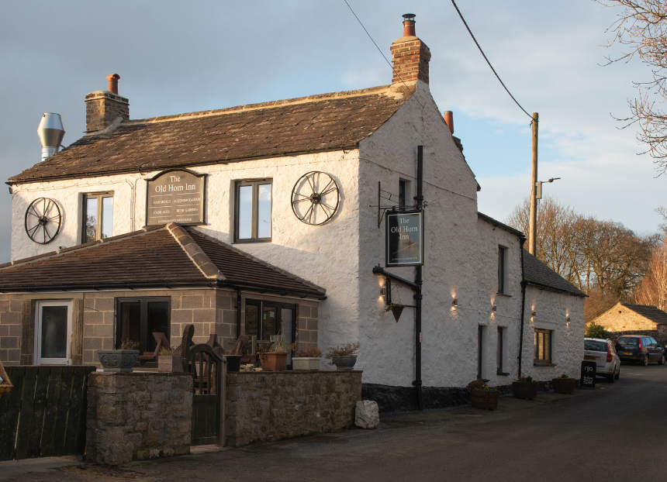

Across the UK, there are groups of people fighting to save their locals. CAMRA’s Pub Saving Awards seeks to recognise and champion those who have come together to save a pub that would have otherwise been demolished or converted to another use. With nominations for the latest Pub Saving Awards now open, What’s Brewing caught up with last year’s winner, the Old Horn Community Pub Society, to see how the inn (above) in Spennithorne, North Yorkshire and its community have fared over the past year since claiming the 2024 title. Chairman of the Old Horn Community Pub Society Richard Wortley said: “In our December 2022 business plan, we stated our mission was to secure the Old Horn Inn as a thriving community-owned enterprise serving the whole of the villages of Spennithorne and Harmby and surrounding areas as a pub and as a broader community asset in perpetuity. “We wanted to ensure social inclusion for all our residents by providing a safe, warm and welcoming environment for all local residents and visitors. The pub has been purchased and completely refurbished having raised more than £450,000 through share offers and grants. The work was completed in the main by local tradespeople and with organisation by a small number of local resident shareholders. “In order to maintain interest in our project we had a ‘pop-up pub’ roughly once a month at the village hall to keep shareholders and the community abreast of events and produced newsletters detailing progress. Following the success of our fund raising we were also fortunate to receive press coverage in local newspapers and visits from local councillors and the MP. We devised a financial plan and modelled various scenarios to see whether the pub could be run profitably. We wanted a free house rather than imposing any brewery ties on our tenant. “Our preference is to adopt the tenant model so we needed to ensure that any tenant could make a reasonable living from the pub. This also had to ensure protection for the Community Benefit Society by way of a deposit as security as well as including terms in the agreement to ensure compliance with the terms of the various grants. “We had to make it clear that as this was a community-owned pub, the tenant is responsible for engagement with the community and is expected to promote and organise community events, particularly those that had been part of the pub’s heritage. These include supporting local sports teams as a post-fixture base such as cricket, football, darts and dominoes, regular quiz nights, coffee mornings and the village Christmas meal. “On 21 September 2024 we had our official opening where we invited two local residents, sisters Norma Croft and Marguerite Mawer to cut the ribbon. This was particularly significant as both women had actually been born and raised in the pub when their father and mother were landlord and landlady from 1936 to 1978. “The tenant has also promoted events such as musical evenings, wine tasting, wreath-making sessions, hosted a knit and natter and has provided a venue for a book group, wakes and more. We are hoping to acquire the use of land adjacent to the pub for outdoor events such as quoits and boules. “Our aim of providing a community hub to combat social exclusion is working and as one local said, ‘we have put the heart back into the village’. “Local beers are provided and encouraging activities has resulted in many residents newly keen to support the pub and its food-and-drink offering. We recognise that the tenant runs his business but is subject to community-activity covenants in the lease.” Nominate a group for the Pub Saving Awards here.