Podcast plugs in to festival

22/08/2025 by WB Reporter

Campaign

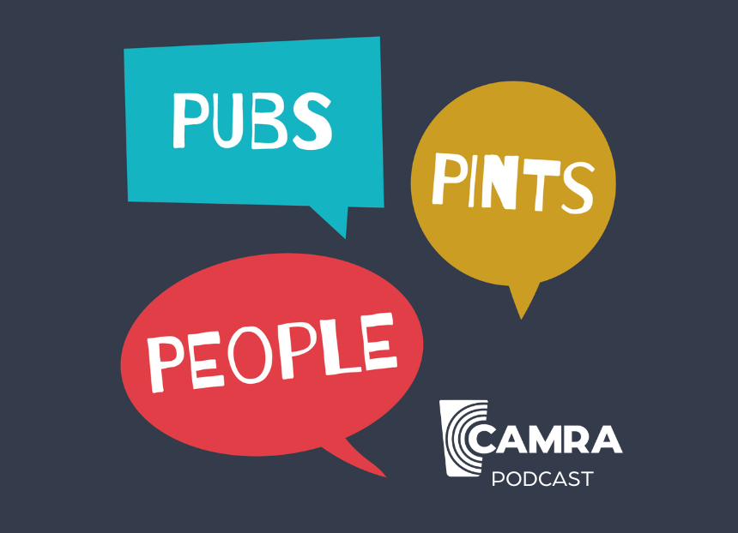

CAMRA’s Pubs.Pints.People. podcast has returned with a new episode recorded at the Great British Beer Festival at the NEC, Birmingham. Welcoming beer and cider fans to the NEC for the first time, podcast hosts Clare Philips, Alison Clare and Simon Webster plus editor David King report on the highlights of the festival’s Trade Event with book launches, beer competitions and interviews with major figures in the industry. The sixth episode of the seventh series features chairman Ash Corbett-Collins talking about CAMRA’s campaigning priorities, highlighting the lack of access to market for independent brewers and cider makers unable to get their drinks behind the bar due to global brewers and pub companies having a stranglehold over the market. Award-winning author Laura Hadland speaks to the team as she launched her Beer Festivals: A Great British Tradition, the first book to detail the history of Britain’s festivals, offering a peek behind the scenes from the last half century. Jonny Garrett from the Craft Beer Channel discusses the ongoing campaign to get cask beer recognised by UNESCO as Intangible Cultural Heritage. The petition needs 100,000 signatures to be debated in government, and you can sign it here: petition.parliament.uk/petitions/716686 CAMRA’s popular educational Discovery Zone is explained by Steve Dunkley in the episode. The programme of brewers and cider makers, including Wilderness and Cidentro plus many more, guided festivalgoers through brewing processes and flavour profiles. Much like the podcast itself, the festival is only possible because of hardworking volunteers. The team interviews volunteers around the festival about what it is like to help out at CAMRA’s flagship event. Low- and no-alcohol beer advocate Ben Gibbs chatted to the team about how the sector is rapidly growing and the specialist bar at the festival. Finally, Penzance Brewing discusses its Champion Beer of Britain-winning brew, Mild. The latest episode is available on Acast, Spotify and Apple Podcast, and wherever you get your podcasts from. You can listen now by visiting: camra.org.uk/about/podcasts