Stockport Crown starts new reign

22/08/2025 by Chris Walkden

Industry

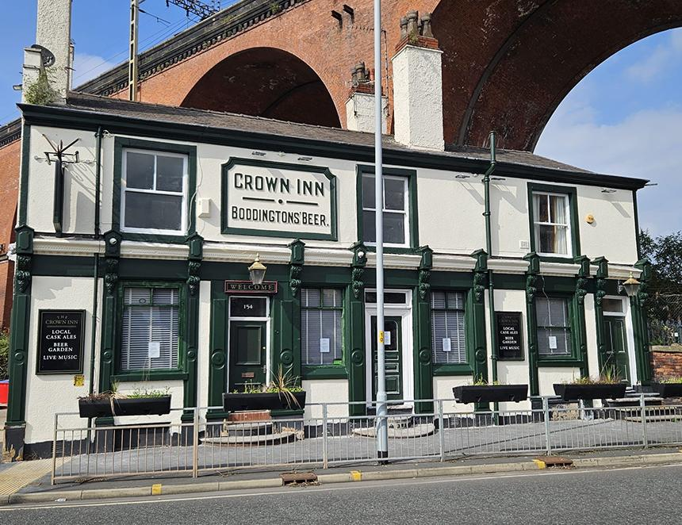

The Crown Inn on Heaton Lane under Stockport’s viaduct has a new lease of life under management which could see Boddingtons return to the bar. The pub was converted from three terraced houses in the late 1870s and by the 1990s, it was a Boddingtons pub. It retains an original relief sign on its frontage bearing the brewery's name and logo.  In the decades surrounding the turn of the century, the pub was known for the quality and quantity of beers from the burgeoning number of microbreweries across the country which were not found anywhere else in the area. In 2009, it was runner up in CAMRA’s Pub of the Year competition. However, since then the place has had mixed fortunes, with several tenants and periods of closure. But now the pub has been revitalised, as the new operators are Alan and Chris Gent, who also run the award-winning Petersgate Tap micropub in Stockport town centre. Alan said: “The Crown got under our skin as far back as 2019, but every time the lease came up, conditions were not right. Nevertheless, we went on what might loosely be called red alert and when the To Let sign went up yet again earlier this year, I contacted the owner, Red Oak Taverns. “Intense negotiations continued for several months and we finally agreed a deal which sees all our eight cask beer pumps and some keg beer taps free of tie, allowing a wider choice from independent breweries. We got the keys on 1 July and immediately set about refurbishing both the interior and exterior of the pub and finally opened on 15 August. “It’s become apparent during this time that the Crown holds a special place in a lot of peoples’ hearts, so we hope the renovation is considered sympathetic and appropriate. Initial signs are promising, and we have already sold three casks of our ‘house beer’, Draught Bass, in the first three days. And who knows, with Boddington’s Bitter being revived, we may be able to feature that beer on the bar once again!” Stockport and South Manchester CAMRA branch chairman John Clarke said: “It’s great to see that one of Stockport’s flagship pubs is once again in safe hands, especially at a time when the hospitality industry is facing many challenges, and scores of places are closing for good. "This area of the town is undergoing a transformation, with many new homes being built, and with the new Interchange now open, the pub is in an ideal area to serve these new residents and visitors. "This addition to our list of excellent pubs and bars in and around the town centre can only enhance the town’s reputation for a great day out. I wish Alan and Chris all the best."