CAMRA unveils UK’s top 16 pubs

21/08/2025 by WB Reporter

Campaign

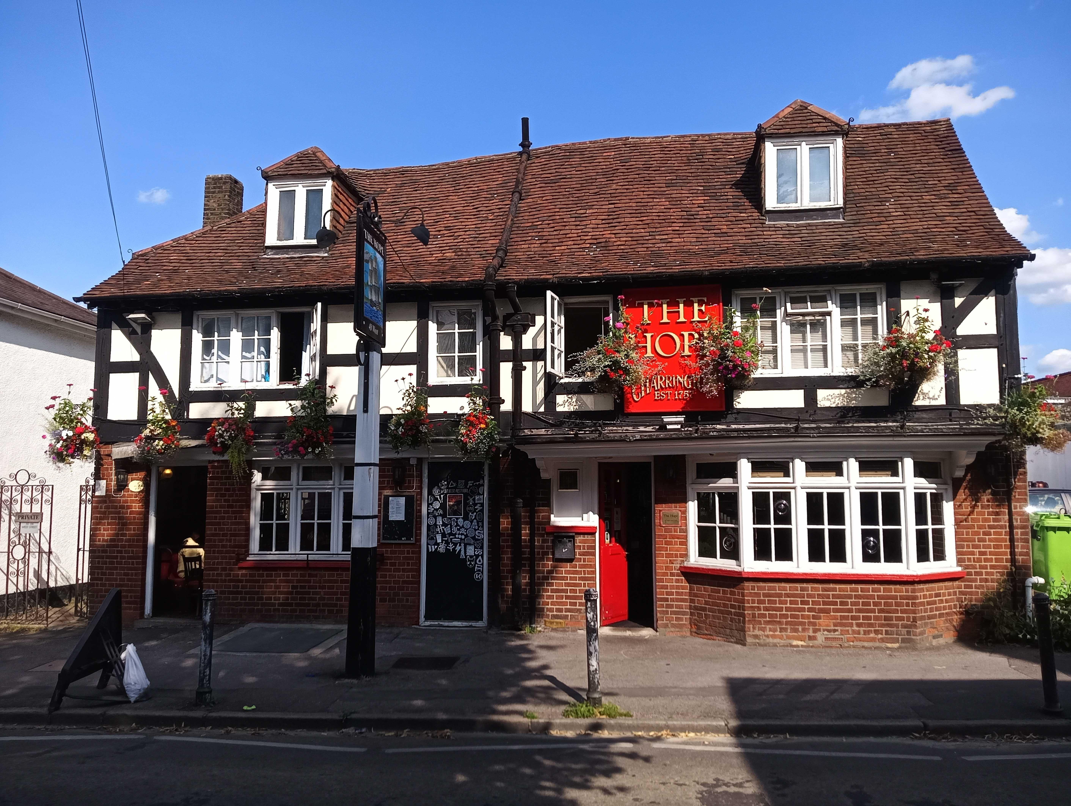

CAMRA has revealed the 16 regional and national winners in its Pub of the Year 2025 competition.  The shortlisted pubs have beaten thousands of entries to be crowned the best in their region or country and will now battle it out for the chance to be named CAMRA’s overall Pub of the Year. The final four pubs in the running for the overall title will be announced in October with the winner revealed in January 2026.  With the bank holiday weekend approaching, CAMRA is encouraging people to get out and enjoy their local or seek out all of these great pubs for a quality pint in great surroundings.  Judges are looking for great atmosphere, décor, welcome, service, inclusivity, overall impression and, most importantly, quality cask beer, real cider and perry.    The 16 pubs have been recognised as the best of the best in the UK and their shortlisting for the competition is testament to their quality and commitment to their communities.   This year’s contest comes as many pubs across the UK face their toughest year yet. They face high costs, high costs, heavy tax burdens and crippling business rates. Pubs need sector specific support, including the reform of the business rates system, an extension of the draught beer and cider duty and a reduction in Employer National Insurance to help with staffing costs.  CAMRA’s Pub of the Year co-ordinator Andrea Briers said: “It is a real pleasure to announce this year’s top 16 pubs, each of which has demonstrated exceptional quality, warmth and dedication to their communities. These pubs are shining examples of what makes the Great British pub so special, from perfectly kept pints to a genuine welcome for all. “Achieving this in the face of rising costs and other pressures is no small feat, and we want to see these pubs, and thousands of others like them, continue to thrive. That’s why we’re calling on the chancellor to give pubs a fair deal in the Autumn Budget, so they can keep serving their communities for many years to come.”  The top 16 pubs are:  East Anglia  Blackfriars Tavern, Great Yarmouth  East Central  Orange Tree, Baldock  East Midlands  Burnt Pig, Ilkeston  Greater London  Hope, Carshalton  Merseyside and Cheshire  Cricketers, St Helens  North East  Station House, Durham  North West  Cumberland Inn, Alston  Northern Ireland  Dog and Duck Inn, Lisbellaw  Scotland  Volunteer Arms (Staggs), Musselburgh   South Central  Bell Inn, Aldworth  South East  Royston, Broadstairs  South West  Hole in the Wall, Bodmin  Wales  Rhos yr Hafod Inn, Llanon  West Central  Pelican Inn, Gloucester  West Midlands  Tamworth Tap, Tamworth  Yorkshire  Beer Engine, Skipton  Pictured: Hope, Carshalton, London Pub of the Year 2025. Photo by Rodger Molyneux