Search on for pub-saving superstars

19/08/2025 by WB Reporter

Campaign

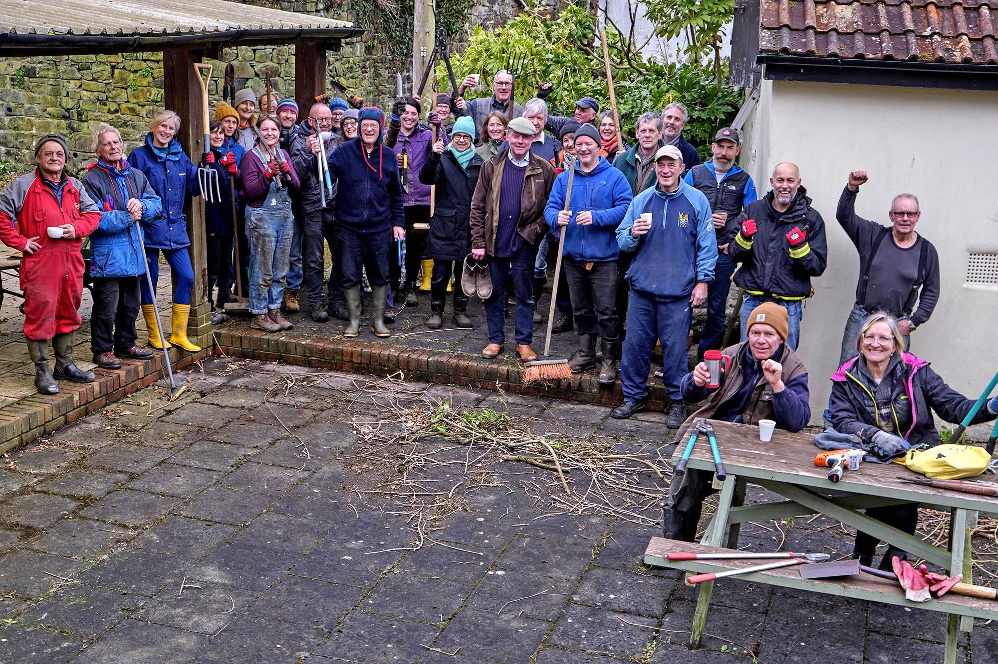

The hunt is on for those tireless campaigners who have come together to save their local as nominations open for CAMRA’s Pub Saving Awards.  The awards celebrates those who have fought to save their pub from demolition or conversion to another use. There is also a Heritage Award recognising the achievements of a group which has revitalised a historic pub.  CAMRA’s Pub Saving Awards coordinator Paul Ainsworth said: “Following the two-year anniversary of the shocking fire and demolition of the Crooked House in Himley, South Staffordshire, the Pub Saving Awards and Heritage Award are more poignant than ever.  “From conversions and demolitions, to simply trying to survive the barrage of increased business rates and Employer National Insurance contributions plus rising costs and spiralling energy bills, it has never been harder for pubs across the UK.   “All the selfless campaigners, who fight for the sake of their communities to save their much-loved locals, deserve to be put into the spotlight. Once a pub closes its doors, it is incredibly hard to prise them open again. The amazing stories and hard work these volunteers describe is a constant source of inspiration – saving your local can be done and I hope that people across the UK are similarly moved to safeguard our precious pubs.  “I can only hope that one day in the future we can add a rebuilt Crooked House to this list of pub saving campaigns.”  Nominations for both awards close on 12 November 2025. The nomination form for both the Pub Saving Awards and the Heritage Award can be found on the CAMRA website here.  Pictured: last year’s Heritage Award winner, the Drewe Arms Community Pub