Voters back easing tax burden on pubs

18/08/2025 by Timothy Hampson

Pub

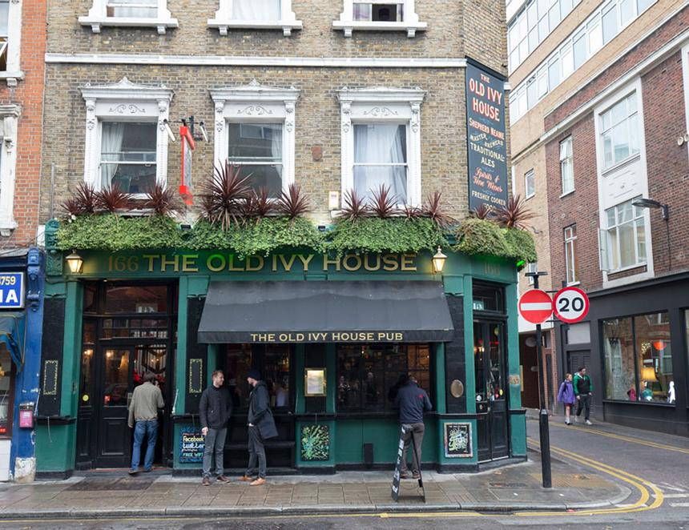

A new poll, commissioned by the British Beer and Pub Association (BBPA), reveals pub business rates has become politically contentious. More than half those surveyed (55 per cent) say they would vote for a party that promises to ease the tax pressure on pubs. Support climbs to 73 per cent among 25-34-year-olds. These findings land as the BBPA warns that without meaningful business rates reform, Britain’s locals and breweries will struggle to survive and pubs will continue to close at a rate of one a day. The cut from a 75 per cent rate relief to eligible pubs, to just 40 per cent was estimated to cost the pub sector £98m. On top of this, publicans now keep just 12 pence on every pint sold, squeezed not only by unfair tax but also by rising energy bills, staffing costs and regulatory pressures. The BBPA’s Long Live the Local campaign argues the next Budget is the best chance in a generation to secure permanent, meaningful reform of business rates and to embed fairer beer duty. BBPA chief executive Emma McClarkin said: “This data is crystal clear that many see pubs as a lifeline instead of a luxury. However, too many pubs are finding it impossible to keep the doors open when they’re up against so many punishing rates and regulations. “When a pub closes it not only takes away the heart and soul of the community, but hurts working people and their families who rely on those wages. “The government can turn this around by delivering meaningful business rates reforms that will ultimately boost jobs, high streets, and the economy.” The findings show the public agrees pubs are central to communities, as 55 per cent of respondents say a good local ranks in their three most important neighbourhood amenities ahead of schools, places of worship and gyms. And 58 per cent say they have attended or organised an activity such as a playgroup, darts night or book club in a pub during the past year. Despite this role, pubs still pay significantly more in business rates than comparable community spaces. That disparity helps explain why 76 per cent of the public believes pubs that host community services deserve a reduced tax burden. Paul Frost runs the of the Langton in Bristol. He said: “Pubs like ours are seen as the heart of the community by everyone, except the taxman. “We host choirs, toddler groups, charity events, and even a wellness hub, but business rates haven’t caught up with reality. The support just isn’t there, even though we’re doing more than ever to bring people together.” Kate Davidson of the Old Ivy House in Clerkenwell, London (pictured) is fearful for growth at her pub, She said: “We knew it would be tough, but it’s become relentless. We’re growing, but the profits don’t reflect that proportionally. “The pub isn’t just about pints; it’s about lonely people finding connection, students bonding with retirees and parents feeling welcome. That’s the value the current rates system completely ignores.”