PUBlic Affairs round up – August

17/08/2025 by Tori Wood

Campaign

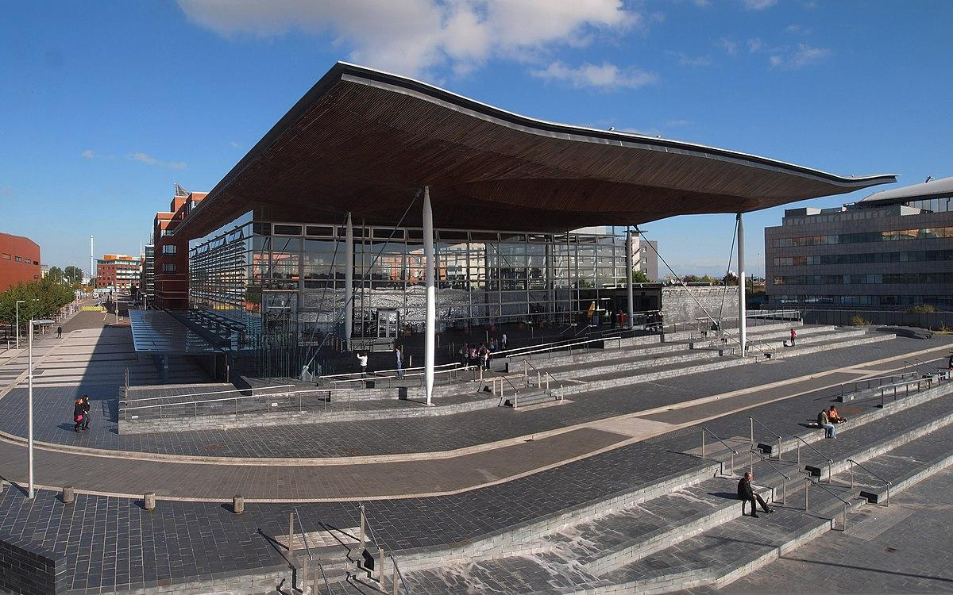

August got off to a great start with the return of the Great British Beer Festival which saw thousands of festivalgoers join CAMRA at the NEC, Birmingham alongside MPs and West Midlands mayor Richard Parker who discussed what can be done regionally and nationally to support pubs and breweries.  It was the two-year anniversary of the destruction of the Crooked House on 7 August, so CAMRA teamed up with #ToastTheCrookedHouse to encourage an international “cheers” to the Crooked House selfie on social media from 4-10 August, with a photo opportunity at the festival.  CAMRA also named festival bars after pubs that have been saved. Members hope the Crooked House will join the list soon.  Read on to find out about how the Campaigns and Communications team is getting on with wider campaigns across Westminster, devolved parliaments and local government.   Westminster  Beer duty  A beer duty House of Commons debate took place on 15 July. CAMRA issued a briefing to all MPs, and shared video extracts of MP speeches on social media.  The team engaged with MPs who participated in the debate such as Will Forster (Lib Dem, Woking) who called the debate and asked for significant duty cuts, Jonathan Brash (Lab, Hartlepool) who called for a guest beer right as part of the Pubs Code for England and Wales, and Jim Shannon (DUP, Strangford) who urged alcohol licensing reform in Northern Ireland.  Responding to the debate, the Treasury said all decisions about beer duty will be announced in the Budget in the Autumn.  10 year health plan The government has published its 10 Year Health Plan for England, although some of the proposals in it will apply across the UK.  On 17 July, Campaigns and Communications manager Paul Edgeworth attended a meeting at the government’s Drinks Industry Forum.   Civil servants from the Department for Health and Social Care spoke about proposals in the plan, including two main proposals.  The plan could see the upper strength threshold for low and no labelled products changed to 0.5 per cent ABV and a new requirement for alcohol labelling to include health and nutritional information. Further information and public consultations will be published in due course.  Licensing review (England and Wales) A licensing task force was convened by the Department of Business and Trade made up of representatives from government, industry and local government.  It reviewed the licensing system, particularly how it impacts on economic growth, cultural life of communities and business costs, with its report and recommendations published on 31 July.  Subject to further work and consultation, the government has accepted the majority of recommendations.  Recommendations include:  create a National Licensing Policy Framework for local councils to deliver a more consistent, transparent and pro-growth licensing system. This will be subject to a consultation over the summer about how this could work in practice

consult later in the year on strengthening the agent-of-change principle in licensing decisions to protect established venues from the impact of nearby developments

exploring ways to support the creation of dedicated hospitality and night-time economy zones

simplify and streamline the process for licensing outdoor seating areas, introducing longer periods and a minimum period of two years

run an amnesty to remove and review outdated and disproportionate licensing conditions

removing the requirement to advertise alcohol licence applications in a local newspaper

review, in the Autumn, the maximum number of permitted Temporary Event Notices.  Planning and community ownership [England only] After meeting with Alex Norris MP about improving planning legislation last month, a Pubs in new housing developments survey has been launched.  It will give examples of large housing developments that have and have not included pubs as community facilities to show the government it should make a local a requirement when building these developments, which is a key CAMRA ask.  Pubs Code for England and Wales As part of the government’s third statutory review and post-implementation review of the Pubs Code for England and Wales, the team created a template email response to the government’s consultation.  The template included CAMRA key asks including the importance of keeping and strengthening the code and its adjudicator, so tied tenants are better protected, and to introduce a guest beer right.  Due to pressures on the government to scrap the code and adjudicator entirely, CAMRA aimed for as many responses as possible to emphasise the need for it to continue. More than 2,400 submissions were made using the template.   The team has also submitted a formal, more detailed response to the consultation.  CAMRA chief executive Tom Stainer went to a Pubs Code Review ministerial roundtable with Department of Business and Trade minister Justin Madders MP on 23 July to emphasise our asks.  Other representatives included the British Beer and Pub Association, British Institute of Innkeeping, UKHospitality, Stonegate, Punch Pubs, Star Pubs, Marstons, Greene King, Campaign for Pubs and Admiral Taverns.  Scottish government and parliament  Scottish Pubs Code All parts of the Scottish Pubs Code are now in full force.  Pub-owning businesses will now be charged a levy to fund the Pubs Code Adjudicator and their office.  Welsh government and Senedd Cymru   Business rates [Wales only] CAMRA has submitted a response to the Welsh government’s consultation on introducing permanent, lower business rates multipliers for small shops calling for pubs to be included too.  Minimum unit pricing [Wales only] The Welsh Government previously commissioned a study from the University of Sheffield on MUP, which it has now published.   MUP first launched in Wales in 2020 with its rate set at 50p per unit. The study examines a price drop to 40p or 45p, a rise to 65p, and changing duties to achieve the same impact on reducing alcohol-specific deaths.  The study investigates how increasing MUP to 65p would see a £14m reduction in revenues, how harmful drinkers spend a fifth of their alcohol in the on-trade compared to 80 per cent in the off-trade, and that increasing MUP would create a bigger impact on these drinkers while increasing duty would impact moderate drinkers in the on-trade.  Welsh government ministers will now produce a proposal for MUP and a future unit price, subject to a public consultation, which the team is drafting a submission.  CAMRA current policy states: “Minimum unit prices should be set at no more than 50 pence and the unit price should not rise by more than the Consumer Price Index in any year that it is raised. We do not believe that there is currently enough published research available on the impact of minimum unit pricing on the on-trade.”  The Senedd’s Health and Safety Care Committee also published a report on MUP last month.  Northern Ireland executive and assembly  NI Licence statistics The NI Department for Communities published 2024 liquor licence statistics in NI on 31 July, which includes public houses and off-licences.  These cover licences by council and district electoral areas split between urban and rural.  Publishing these statistics is a legislative requirement, introduced in 2021 for transparency.   Headline figures since then include:  2024: 1,123 licences in operation for public houses and 678 for off-licences.  2023: 1,109 licences in operation for public houses and 655 for off-licences.  2022: 1,089 licences in operation for public houses and 641 for off-licences.  2021: 1,193 licences in operation for public houses and 637 for off-licences.  NI Licensing Review The University of Stirling published an independent review of Northern Ireland’s alcohol licensing in February.   The minister is due to respond by 20 August.