A festival for all?

16/08/2025 by Matthew Curtis

Opinion

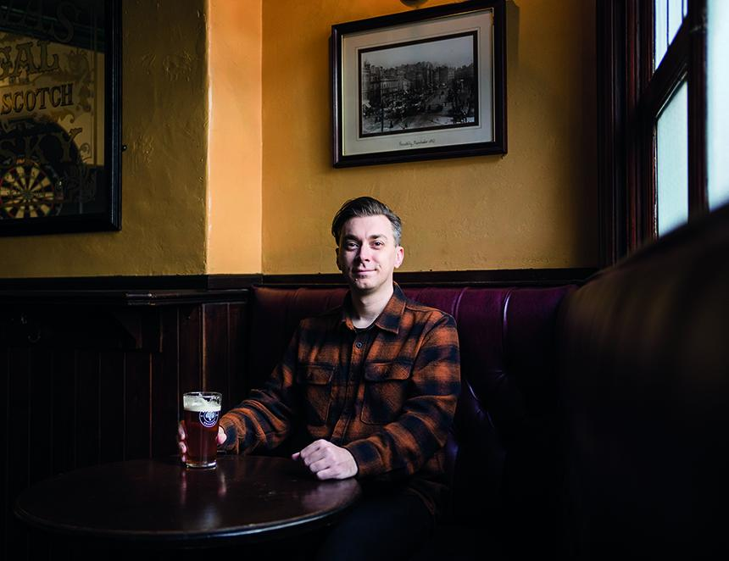

There was a palpable sense of anticipation ahead of the announcement of this year's Champion Beer of Britain. As the clock ticked closer to 4pm, various members of the brewing industry and associated press gathered around the main stage at the Great British Beer Festival (GBBF), this year held at the NEC in Birmingham. I recognised various faces in the crowd, from former Fuller’s brewing director John Keeling, to veteran journalist, and fellow What’s Brewing columnist Roger Protz. While Roger was diligently taking notes and photographs, I stuck to the small talk, trying to keep an eye on the body language of my two personal favourites in the competition: Berkshire’s Elusive Brewing, nominated for its Oregon Trail IPA, and Manchester’s Track Brewing, in the running with its Sonoma pale ale. Judging by their ashen (yet still smiling) faces, and hunched shoulders, I imagined the 14 team members who travelled down from Track were just a little bit nervous. Plenty of people had their colours on display, including John O’Donnell of CAMRA’s Trafford and Hulme branch, who was sporting a custom-made Elusive Brewing shirt. I was rooting for Track, having followed the brewery since its inception in 2014, I would have dearly loved to see it bring the prize back to Manchester. Sadly it wasn’t to be, as largely malt-forward beers wowed the judges on the day. Cornwall’s Penzance Brewing took home the top prize with its fabulous nutty, dry and moreish Mild. The announcement sent rapturous applause around the NEC as the brewery deservedly claimed its trophy. Local Sarah Hughes brewery took silver with its Snowflake barley wine, and Nuneaton’s Church End Brewing finished in third with Fallen Angel, a 5.1 per cent, bright and full-bodied pale bitter. Three superb beers, each of them a fabulous representation of what Britain’s independent brewers have to offer.  Also notable was the bottled beer category, where St Austell’s Georgina Young made it a Cornish double when she was presented with the gold medal for Proper Job IPA. Notably, both gold and silver in this category were claimed by female head brewers. This point was celebrated by CAMRA’s Christine Cryne as she handed over the awards, with Pam Honeyman of Monty’s brewery in Powys taking silver for Mischief golden ale. There was much to celebrate on the day, including GBBF itself, after it had to take an unfortunate fallow year in 2024 due to problems in securing a venue. It was also the first time the festival had been held outside London since 1990 (it went to Brighton) and had returned to Birmingham since 1983. I was glad to see the festival had moved away from London. I understand the capital is a great focal point for many, but Britain’s brewing culture is not tied to one city alone, and those of us from the North like myself were glad of the venue being within a shorter distance. It was also a great chance for people to experience just how vibrant Birmingham’s beer and pub scene is. Beer lovers were able to flock to city-centre venues like the Colmore and Woodman, while also checking out local breweries such as Attic Brew Co. and Indian brewery. For me, it also provided the opportunity for a day trip to the nearby Black Country, and to experience beers from Batham’s and Sarah Hughes in the flesh for the first time. The arrival of GBBF was during a tumultuous time for the local hospitality scene, with cherished city-centre venues including Tilt and the Post Office Vaults having closed mere weeks before the festival began. Hopefully, with the festival in residence, it gave the local beer and pub scene a vital boost and encouraged people to return and dig a little deeper beneath its surface for themselves. As for the festival itself, for me it felt positive to see cask beer once again being represented on a national level. Although I felt the layout of the venue could do with a bit of tinkering for next year, with certain beers being hard to find, and everything feeling just a bit too spread out to be cohesive. However, there were also reports of unfortunate, sexist behaviour from male attendees during the Trade Event. I’m glad beer marketer and influencer Kimberley Spivey has spoken about this. If festivals are to be a safe and welcoming space for all, then these stories need to be shared, and people need to act when they are. It is far from the first time women attending the GBBF have shared stories like these, and it is particularly concerning that the incidents stated in Kimberley’s piece occurred during the Trade Event, which is exclusively attended by members of the brewing and pub trade, plus the press. Perhaps CAMRA needs to approach this in the same way football grounds deal with racism or hooliganism. There should be no place for sexism at GBBF, and where it occurs, individuals should be reported and handed a lifetime ban. Employers too should consider disciplining individuals behaving in an unacceptable way. While events like GBBF remain male-dominated, we need to take responsibility in calling out bad behaviour when we see it and work together to ensure events like these can be safe and accessible for all.