Community pub ownership bulletin – August

15/08/2025 by WB Reporter

Campaign

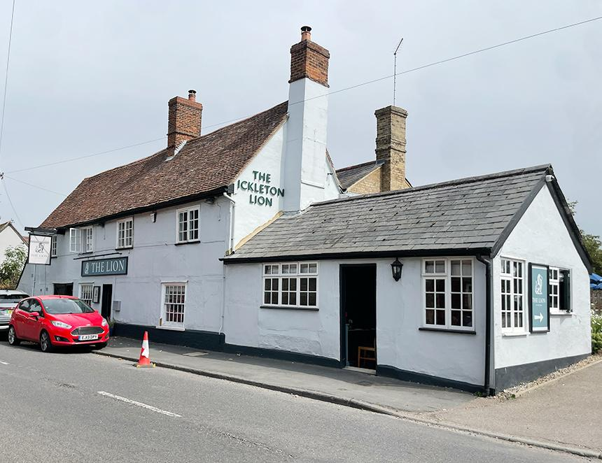

Since April’s bulletin, the number of community-owned pubs (COPs) has increased from 217 to 223. Those not owned but run by the community remain at 28 and the number of active campaigns is still 78, though that hides a degree of churn with some campaigns coming to fruition, others failing and new ones coming along. CAMRA supports the community-ownership model and is keen to assist those interested in going down this road. The community-pubs webpage of CAMRA’s website contains advice and guidance as well as regularly updated information about existing and planned projects. Community Right to Buy Government recently published the English Devolution and Community Empowerment Bill which will deliver the promised Community Right to Buy, giving groups first refusal on the purchase of Asset of Community Value (ACV)-listed properties that are put up for sale. The current ACV regime offers groups only a “right to try” and owners can ride out the six-month moratorium period with no obligation to sell. Under the new scheme, once the property is put on the market, a community group can enter negotiations with the owner. If a price cannot be agreed, then an independent valuer will set the figure based on market value. The moratorium period will be extended to 12 months. Owners will be able to ask the local authority, six months into a moratorium, to check that community groups are making sufficient progress to raise the necessary funds. Nominating groups will be able to appeal against a local authority’s decision to refuse an ACV application. Presently, only owners have a right of appeal. Local authorities will be supported to deliver the new powers with revised guidance. This is positive development. At present, there are many instances of owners putting ACV-listed pubs on the market at inflated prices that effectively put a halt to any meaningful purchase negotiations. In future, the sale price should be a fair one, reflecting the property’s value as a pub rather than as a development site. The changes also give a boost to the ACV regime itself. Having that status will significantly increase the chances that a pub can be bought by local people for a reasonable price. CAMRA will continue to work with civil servants on the detail of the Bill’s provisions, paying particular attention to the revised ACV guidance for local authorities and look to address the many omissions and ambiguities in the existing documentation. Campaign news Bridge Inn, Whorlton, Durham Residents are fighting to save their local after plans were lodged earlier this year to turn it into a house. Their goal is to raise £400,000 to buy and renovate the pub and have already secured more than half. More information about the Whorlton Community Benefit Society and the campaign can be found on its Facebook page here. Anglers Rest, Bamford, Derbyshire Saved by the community in 2013, the pub was reported last year to be “in peril” having struggled financially due to rising costs. Happily, a solution has been found by appointing an experienced licensee with a reputation for saving pubs in distress. New Clarence, Hull In 2023, the owners of this much-loved, city-centre pub put it up for sale after an application for change of use to a house in multiple occupation (HMO) was refused. The Hull Community Pub Society was quickly formed and by April 2024 it was able to offer the owner the asking price, which was declined. Further change of use applications were refused and last November a sale was finally agreed. Renovation is ongoing and in advanced stages plus a manager and chef have been hired. Find more information here. Lion, Ickleton (above) Closed since July 2023, the Lion reopened 29 June after residents of Ickleton, Cambridgeshire raised £440,000 to buy the pub from Greene King. The 300-year-old pub has been undergoing tasteful renovation since last December. Ploughman, Wigton Scotland’s newest community-owned pub opened at the end of March after an army of volunteers including nearly 450 members of the Wigtown Community Inn Community Benefit Society worked hard to get the pub operating again. The building will also be used as a daytime community space during the week. Punch Bowl, Burton-in-Lonsdale, North Yorkshire This grade II-listed ACV pub dates back to the 1700s. The Punch Bowl Inn, Burton in Lonsdale Ltd purchased it on 4 July and refurbishment work began immediately with volunteer support, with the aim to reopen by Christmas 2025. A manager is currently being recruited. Get involved with the renovation work here. Bird in Hand, Henstridge, Somerset The current owners wish to retire and enthusiastically support the Bird in Hand Society’s efforts to purchase and run the pub. So far £120,000 has been raised towards the £550,000 required. Find more information about the campaign here. Bayford Inn, Bayford, Somerset Having bought the pub at auction in late 2024, the Bayford Inn Benefit Society is hard at work on an extensive refurbishment. It hopes to reopen soon. If you have any information about community ownership developments in your area, particularly any new campaigns, send updates to info@communitypubs.camra.org.uk If your pub has closed or under threat, CAMRA's website has in-depth guides and resources, including those about community pub ownership, to help save your local here.