Shires take step back in time

12/08/2025 by Timothy Hampson

Industry

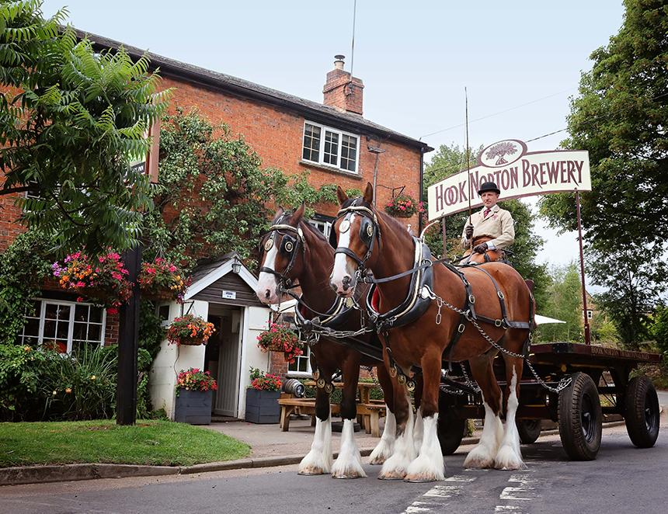

Hook Norton is reviving a beloved tradition as it resumes beer deliveries by shire horse and dray. The brewery will be delivering to the Pear Tree, bringing back a nostalgic touch to its local distribution. The delivery team will be led by Brigadier and Balmoral, two of the brewery’s shire horses under the experienced guidance of head coachman Nicholas Carter and groom Alyster Mills. Nicholas said: “There’s something incredibly special about delivering beer the traditional way – it’s a living link to our brewing heritage." The horses, including a third shire named Cromwell, are stabled on site at the brewery and are available to visit seven days a week. Hook Norton is now one of only two breweries which still delivers using shire horses. To find out more follow on Facebook or visit hooky.co.uk/hooky-shire-horses