Spoilt for choice in Norfolk

11/08/2025 by Timothy Hampson

Campaign

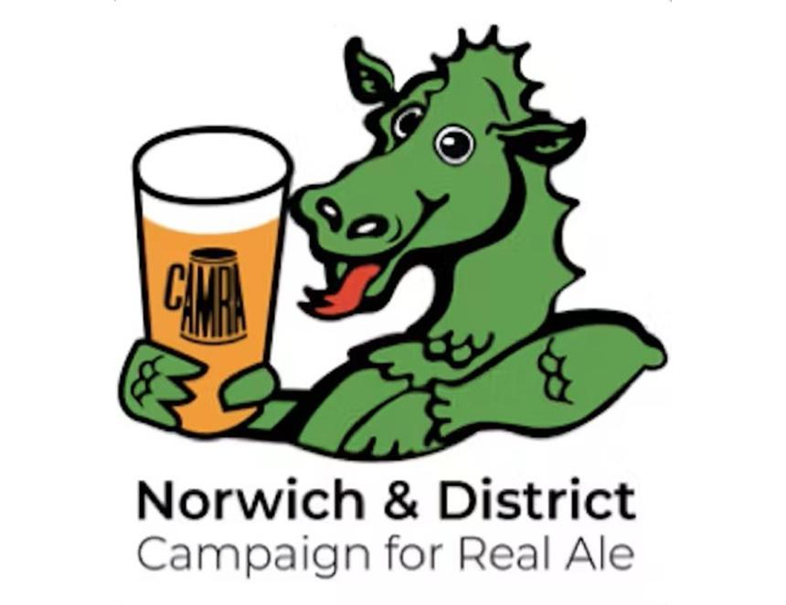

Beer lovers across Norwich and the surrounding district are spoilt for choice, according to the latest results from the area’s CAMRA branch pub survey. A record-breaking 63 volunteers visited more than 430 pubs in one day, covering nearly the entire branch area for the first time in the annual survey’s history. This year’s survey uncovered 389 cask beers on sale across the Norwich and District branch area, including 265 in the city alone. The growing diversity of beer choice was also clear, with fewer pubs tied to just a handful of big brands, compared to previous years. Drinkers are paying slightly more for their beer. The average price of a pint of cask beer in Norwich is now £4.68, up six per cent from last year and 24 per cent from 2019, which is unsurprising given increased costs in production, distribution and pub running expenses. Across the wider region, the average pint costs £4.73. Branch chair Ian Stamp said: “Despite rising prices, real ale remains excellent value compared to other drinks and we’re delighted to see an expansion in choice, despite escalating costs and new challenges facing the industry. “The rise in popularity of beers from smaller, local breweries might be attributable to the rise in numbers of them, the quality across local microbreweries and also their appeal to those seeking greater choice and new beers of different types, strength and flavour.” While the big brand names like Adnams Ghost Ship, Southwold Bitter and Broadside, Greene King Abbot and IPA, Sharp’s Doom Bar, Lacons Encore, Bloom and Legacy, Timothy Taylor’s Landlord and Woodforde’s Wherry and Nelson’s Revenge came out on top, the presence of beers by smaller breweries has grown significantly over the years, often now appearing in multiple pubs across the region, showing an increase in popularity for less-known microbreweries. Moon Gazer’s Pintail and Cheeky Jack appeared most popular of the smaller breweries within the branch area, followed by Wolf’s Golden Jackal, Barsham's Oaks, Grain’s Threeonesix, Oakham’s Citra, Thornbridge’s Jaipur, Green Jack’s Trawlerboys, Moon Gazer’s Amber, Wolf’s Edith Cavell, Lontra by Mr Winter’s and All Day Brewing, Little Sharpie and Idaho Heaven by Humpty Dumpty, Fat Cat’s Norwich Bitter and Marmalade Cat, Barsham’s Eastern Gold and Norfolk Topper, Morland’s Old Session Hen, Oakham’s JHB, Moon Gazer’s Ruby, Wychwood’s Hobgoblin Gold, Green Jack’s Golden Best, Mr Winter’s Peach Tea plus its Twin Parallel and Lets Cask, Hop Back’s Summer Lightning, Beeston’s Worth the Wait, Black Sheep’s Best Bitter and Wolf’s Lupus Lupus. Of the remaining 325 beers featured within the area, they were each spotted between one and three times. In the wider branch area, Woodforde’s Wherry emerged as the most widely available cask beer, spotted in 55 county pubs and 62 in total. Local breweries shone brightly throughout the region, with Lacons, Moon Gazer, Barsham, Wolf and Grain all making strong appearances, alongside regional giants Greene King and Adnams. Survey organiser Craig Harmer praised the dedication of the volunteers: “We’re incredibly grateful to all the volunteers who gave up their time to help us complete this enormous survey.  “Visiting more than 430 pubs in a single day is no small feat. These results show not only the fantastic range of beers on offer in our region, but also the crucial role that local pubs and breweries continue to play in our communities.” The branch hopes the results will encourage more people to explore their local pubs and discover the wealth of beers available.